**Design Patterns – Udemy course**

1. **SOLID**
   1. **SRP – Single Responsibility Principle**

Each class should have only one sole purpose, and not be filled with excessive functionality. In other words, each class should have only one reason to be modified.

* 1. **OCP – Open-Closed Principle**

Classes should be open for extension, closed for modification. In other words, you should not have to change an existing class for implementing new features.

* 1. **LSP - Liskov Substitution Principle**

This means that every subclass or derived class should be substitutable for their base or parent class.

* 1. **ISP - Interface Segregation Principle**

Interfaces should not force classes to implement what they can not do. Large interfaces should be divided into small ones.

* 1. **DIP - Dependency Inversion Principle**

High-level module should not depend on low-level module. Instead, all of them should depend on abstractions, not on concretions.

**Runtime.getRuntime().exec(“notepad.exe ” + filename)** – this will show us the content of the file on Windows in Java.

**OCP + Specification (enterprise design pattern)**

**ISP + YAGNI = You ain’t going to need it (not to implement excessive functionality).**

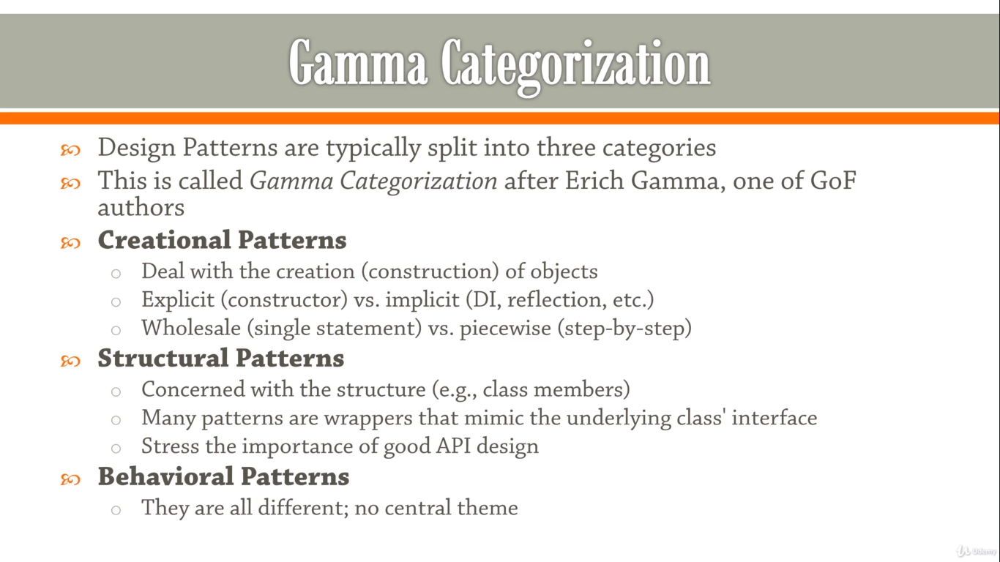**Gamma Categorization of Design Patterns**

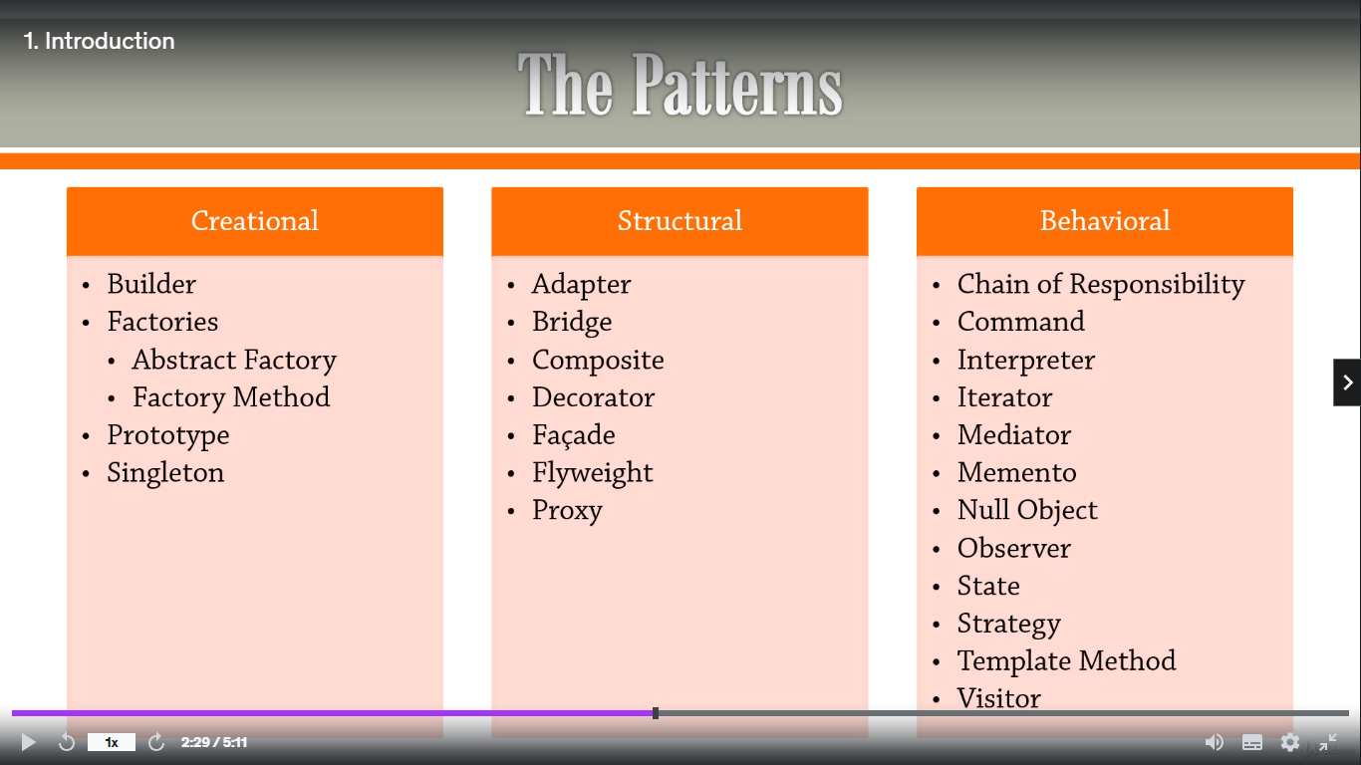

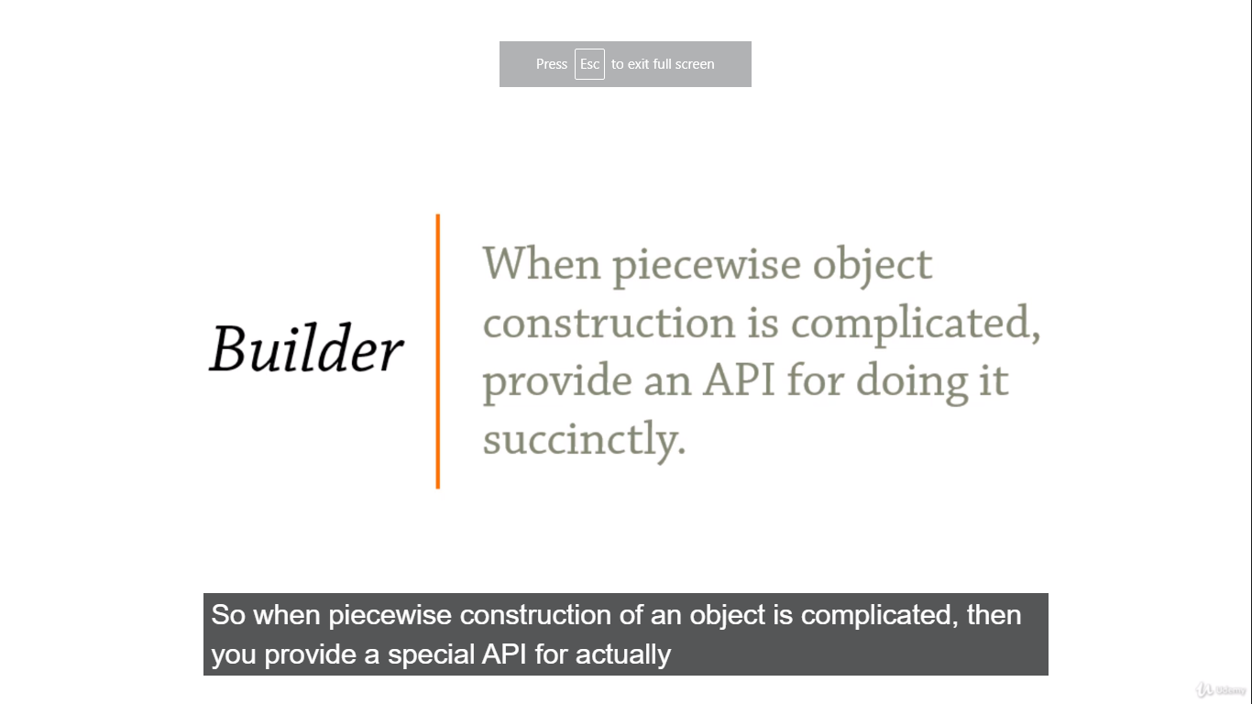**Creational Design Patterns: Builder**

“When piecewise object construction is complicated, provide an API for doing it succinctly”

The main idea is:

* To create the class for object (**class Item**, for instance) which construction is too complicated by doing so by usual wholesale way.
* To create the class of builder (**class Builder**, for example) which has the **Item** object as a private property and has a set of methods to construct the separate part of it(addName, addAddress and so on).
* In the constructor of the Builder class, we set the root item private property – an object which we actually would like to create by using this Builder.
* Each of the mentioned methods of the builder returns ‘**this’** pointer of the current Builder class to give us an opportunity to build the desired object step-by-step (builder.addName(‘Olha’).addAddress(‘ ’) and so on).
* If we would like to use two or more builders to construct the object we should inherit them from the façade builder (class Builder() - parent, class JobBuilder - child, class PersonBuilder - child).

**Creational Design Patterns: Factories**

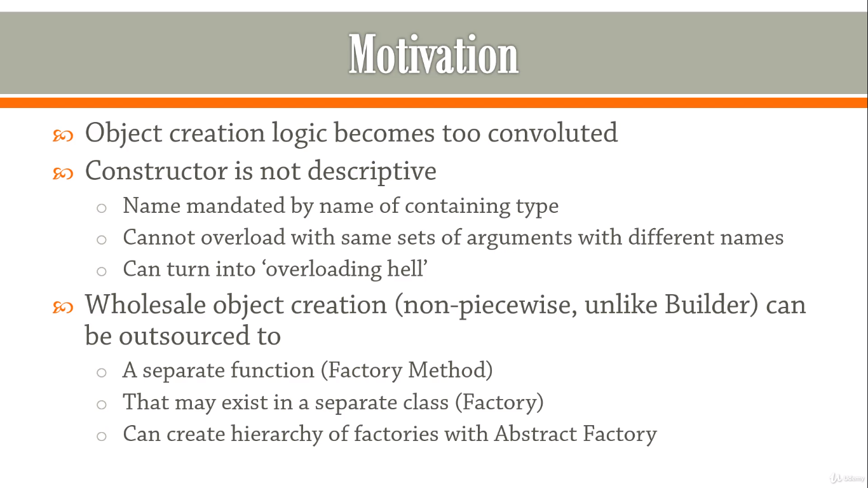

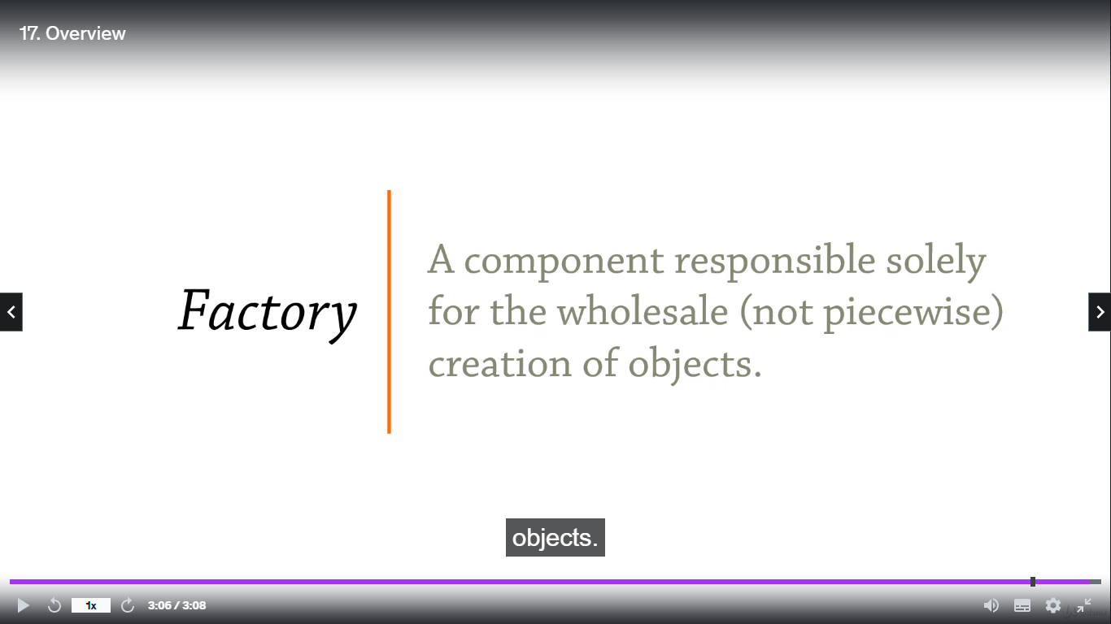

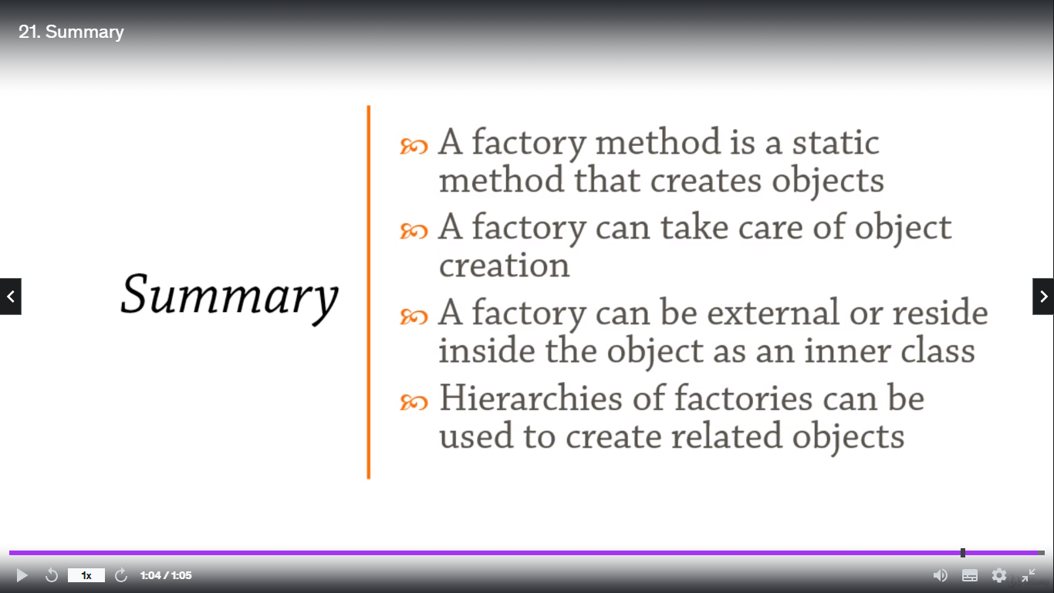

**Creational Design Patterns: Prototype**

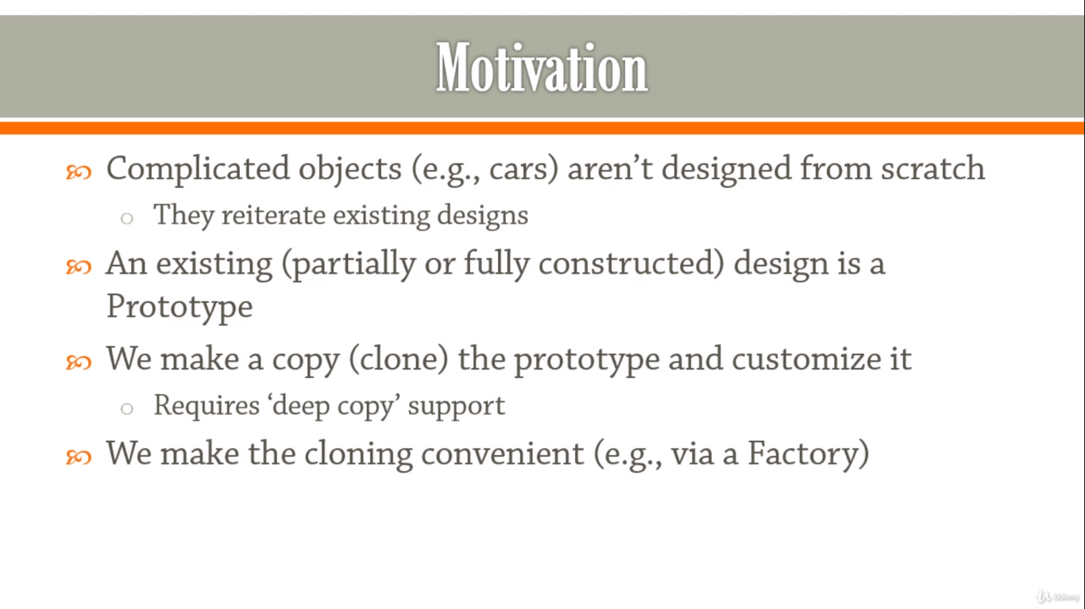

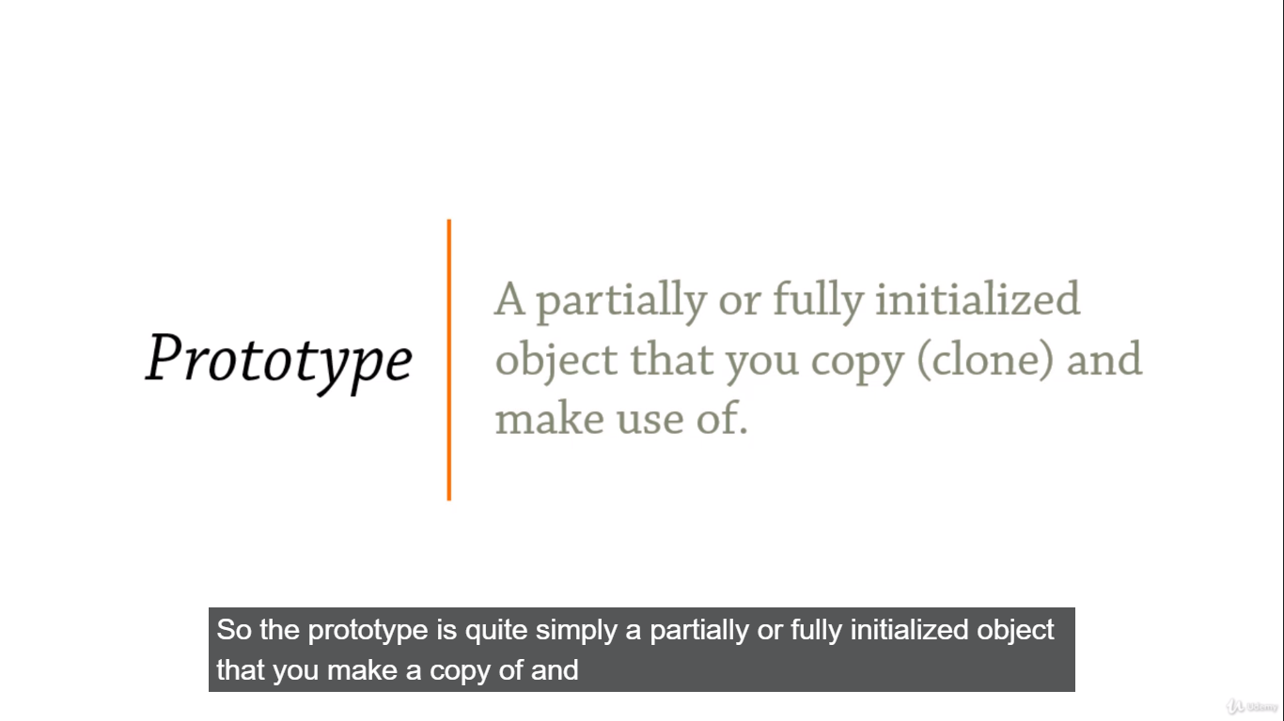

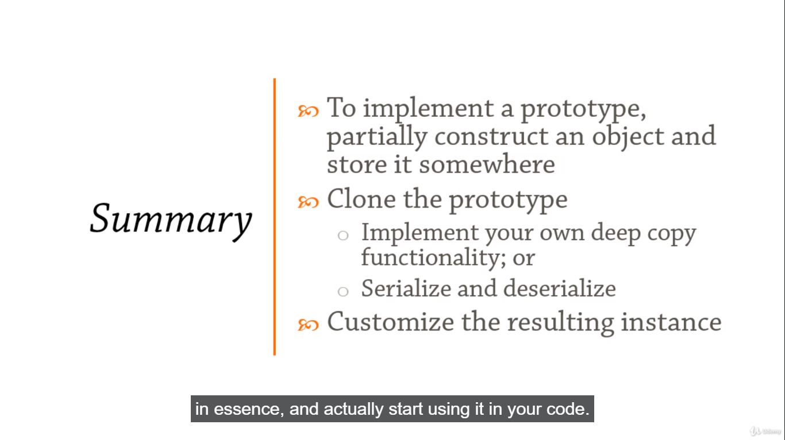

**Creational Design Patterns: Singleton**

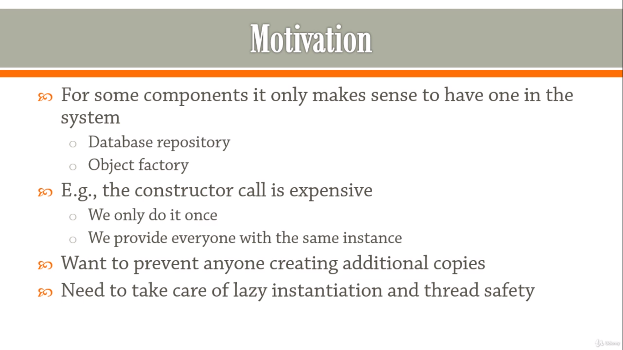

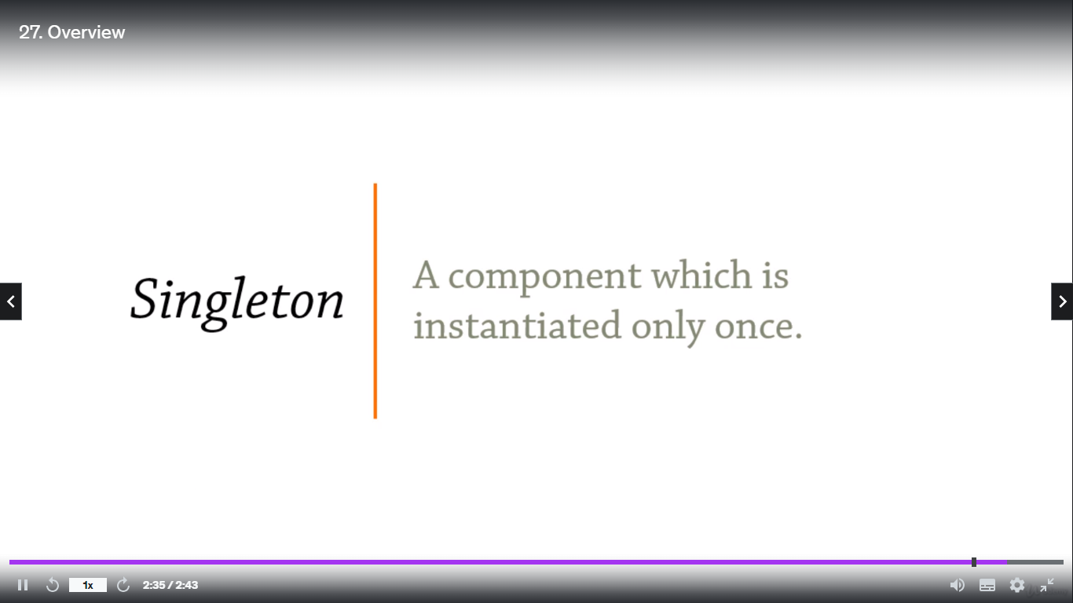

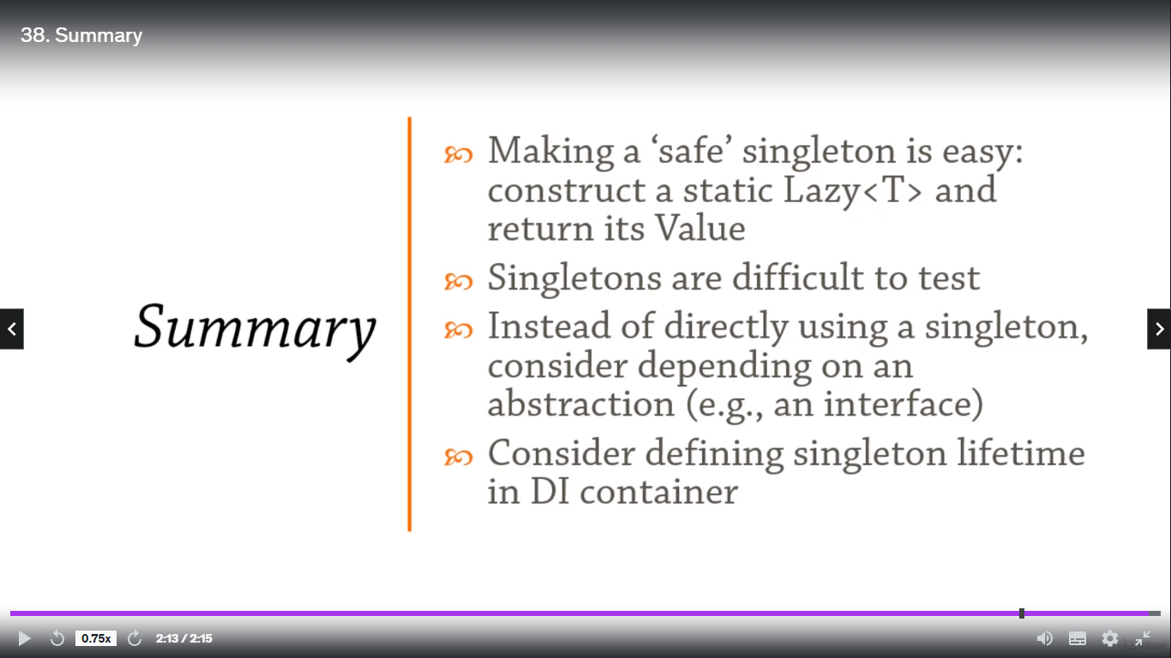

**Structural Design Patterns: Adapter**

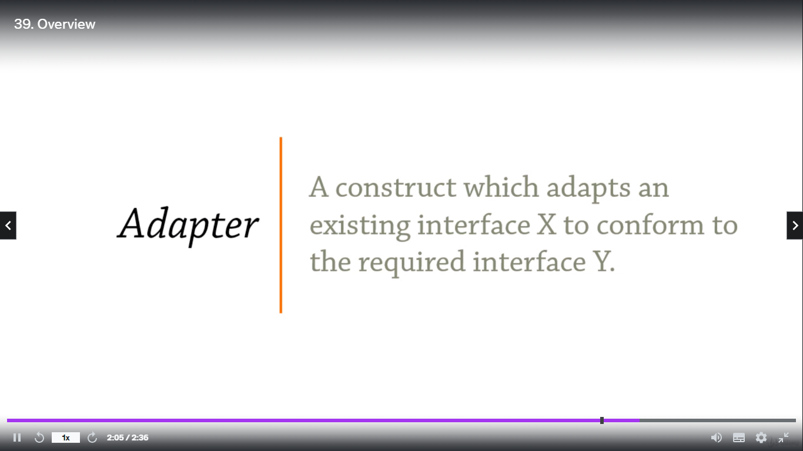

**“Getting the interface you want from the interface you have”**

The takeaway from the entire lesson is the following:

* If you implement the adapter pattern, sometimes the adapter will generate temporary objects. And if you want to avoid the extra generating of those objects, then you build a **cache**.
* We can make a static map, which contains the mapping from the hashes over the lines we need points for to a list of corresponding points. And then we go into this cache and look for the appropriate points before we actually go off and regenerate them.

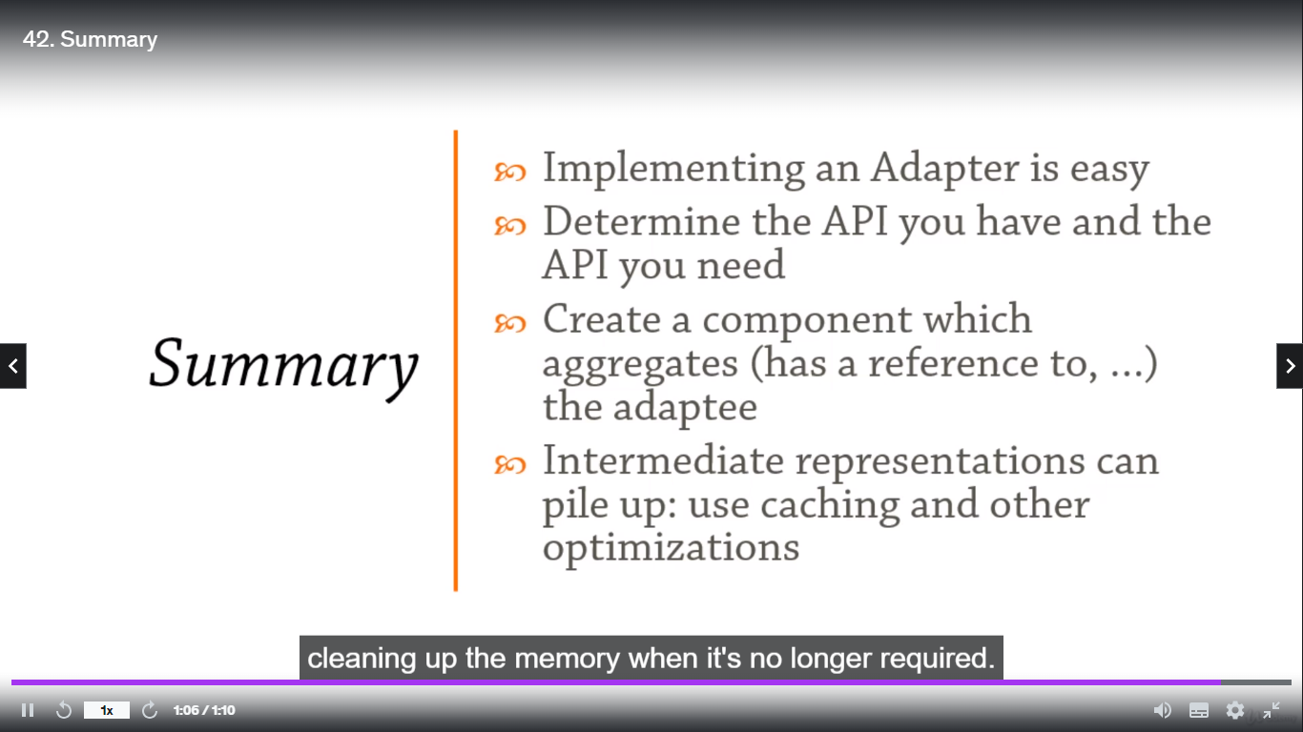

**Structural Design Patterns: Bridge**

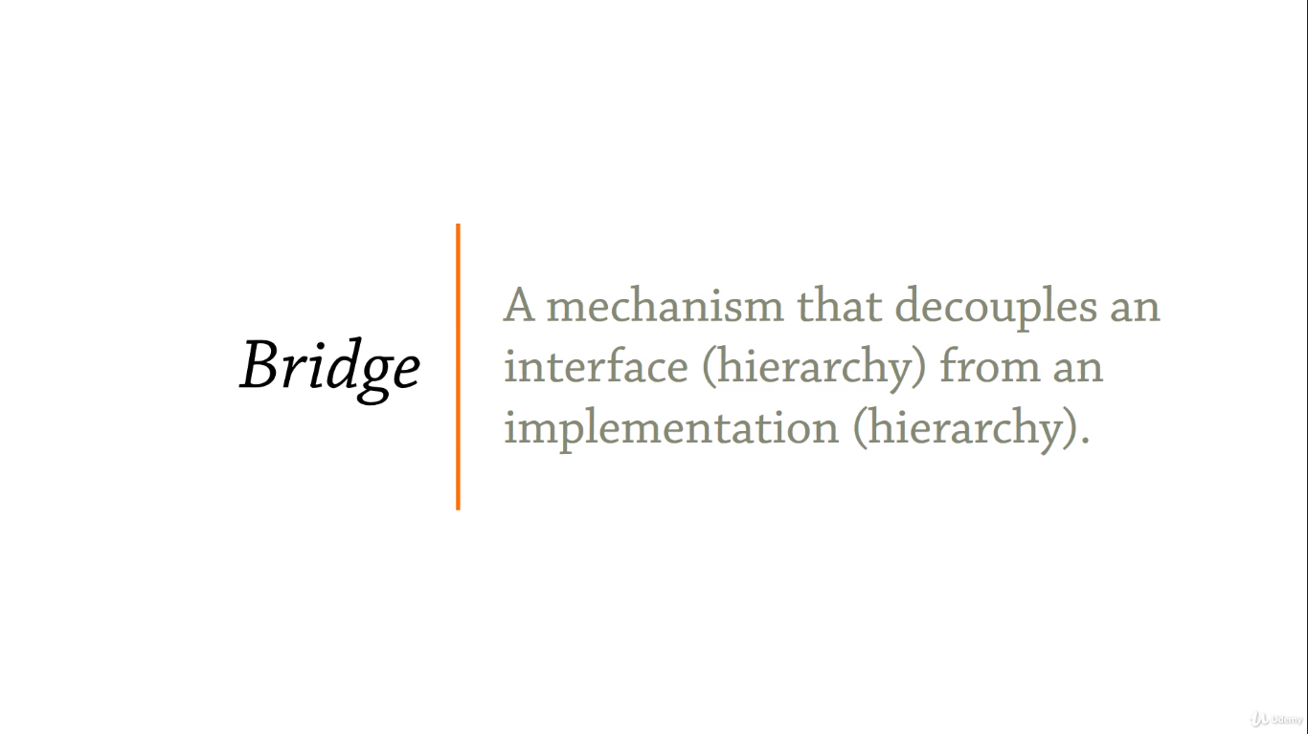

**“Connecting components together through abstractions”**

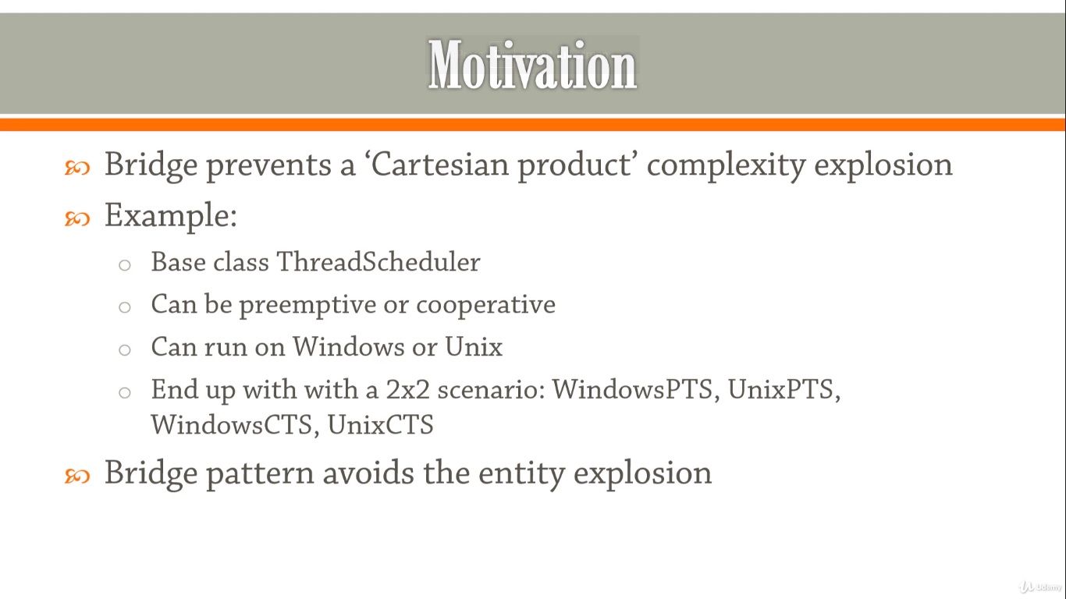

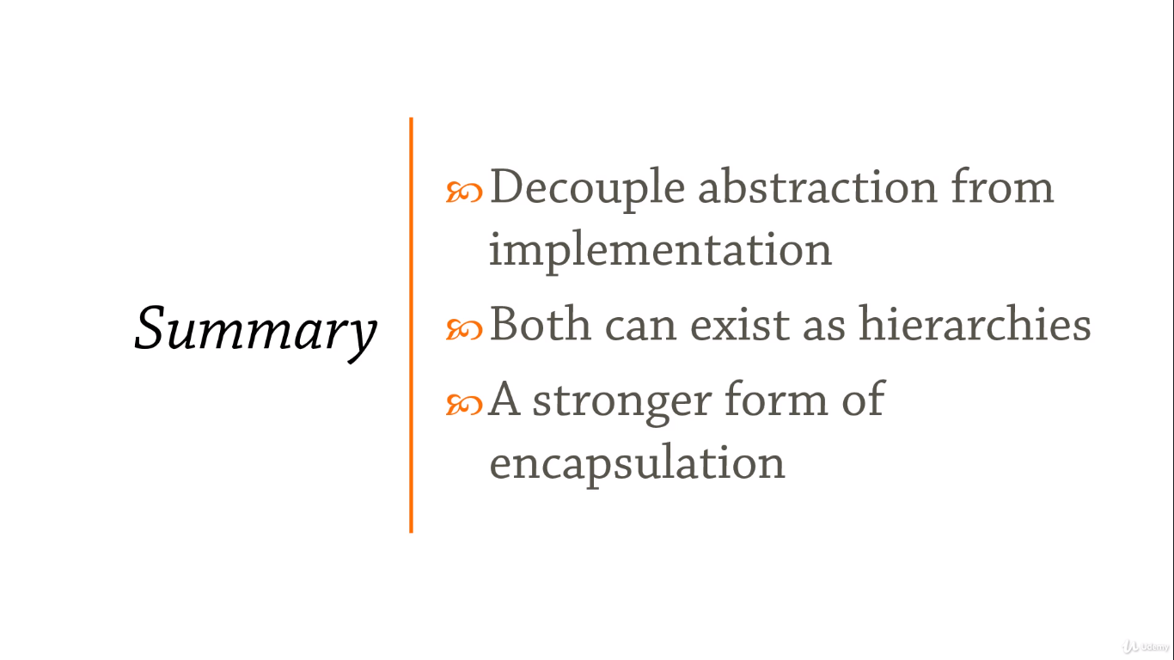

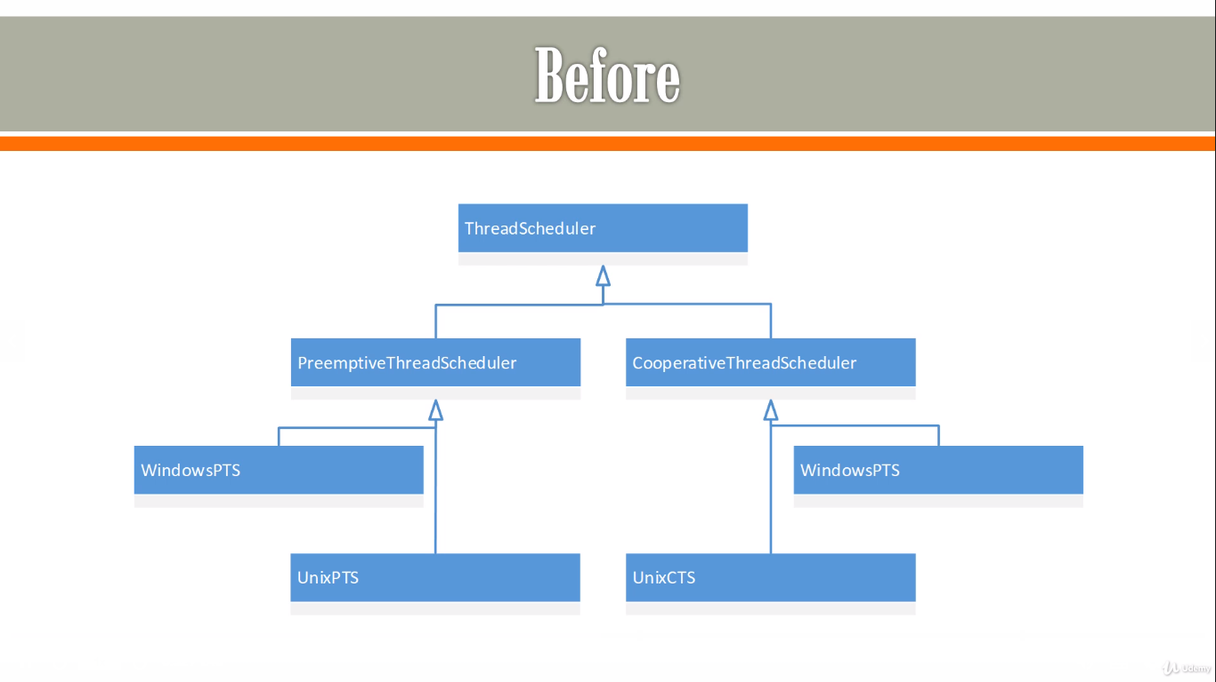

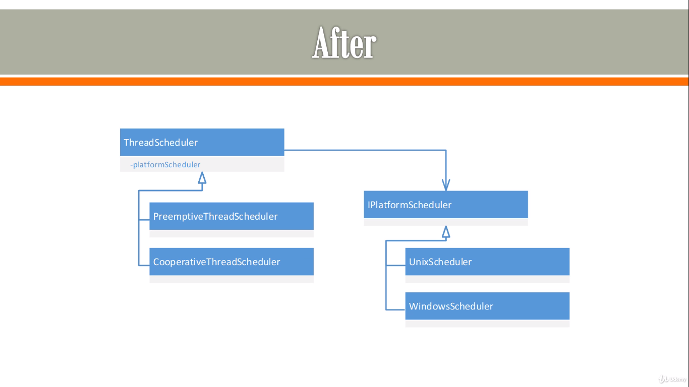

**Structural Design Patterns: Composite**

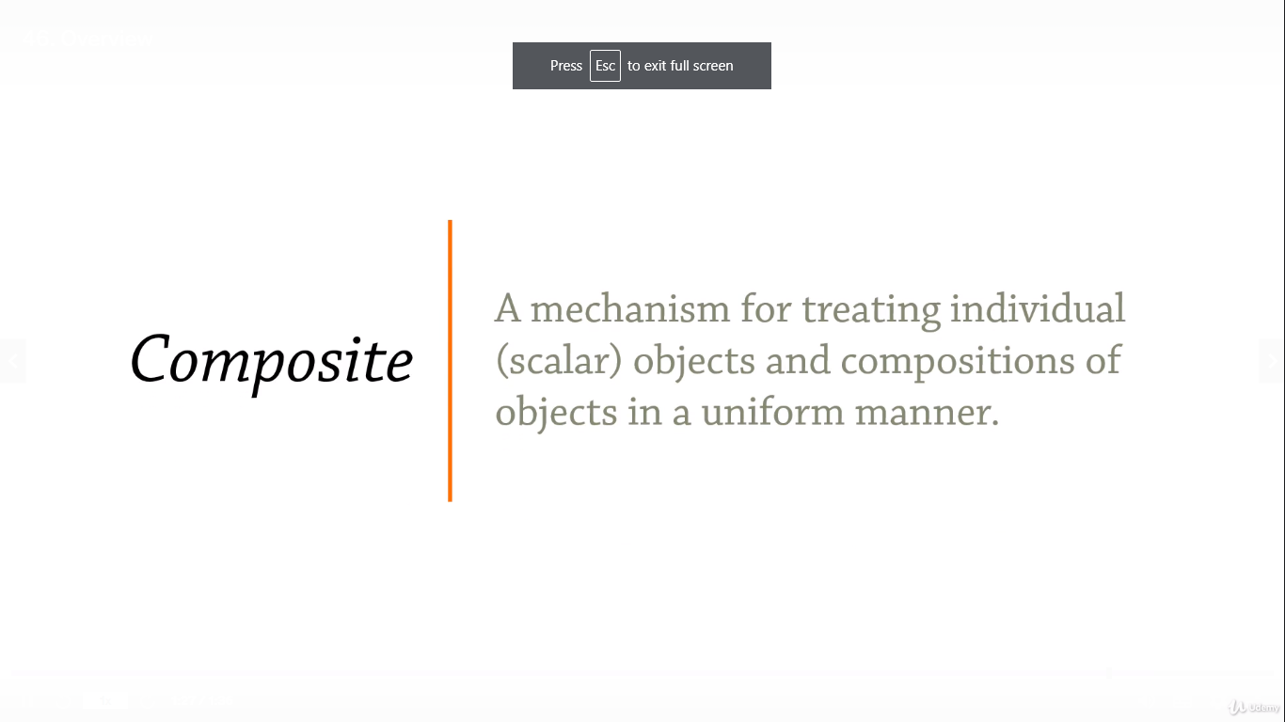

**“Treating individual and aggregate objects uniformly”**

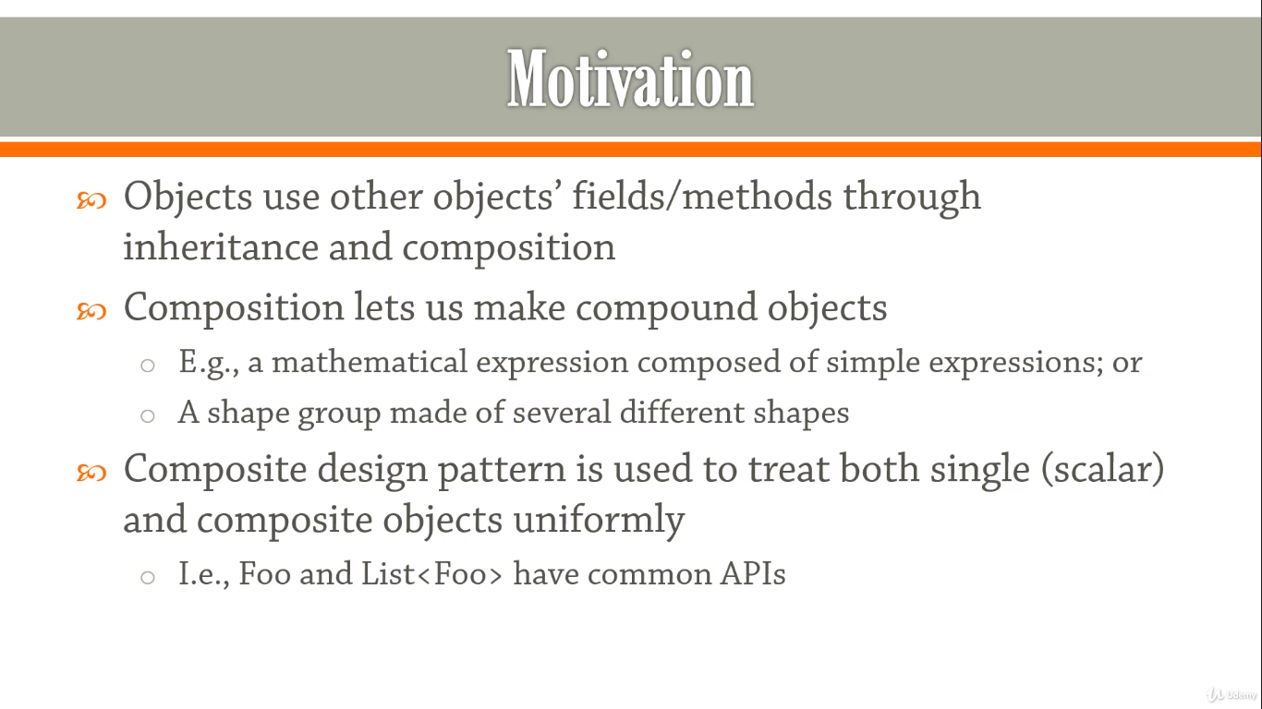

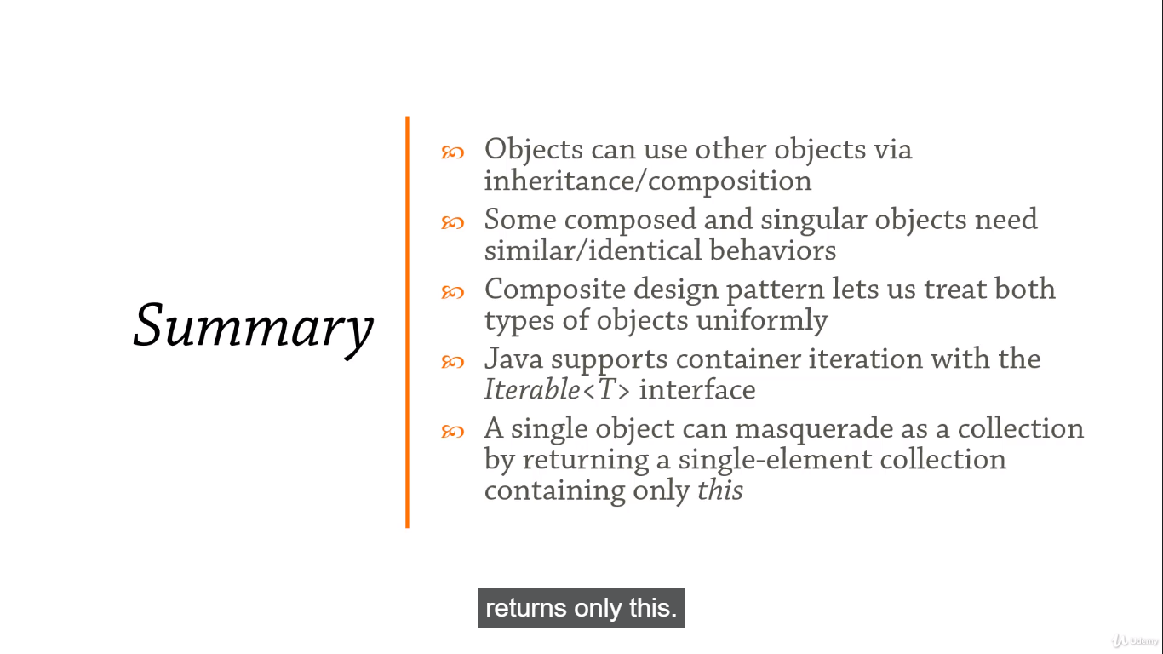

**Structural Design Patterns: Decorator**

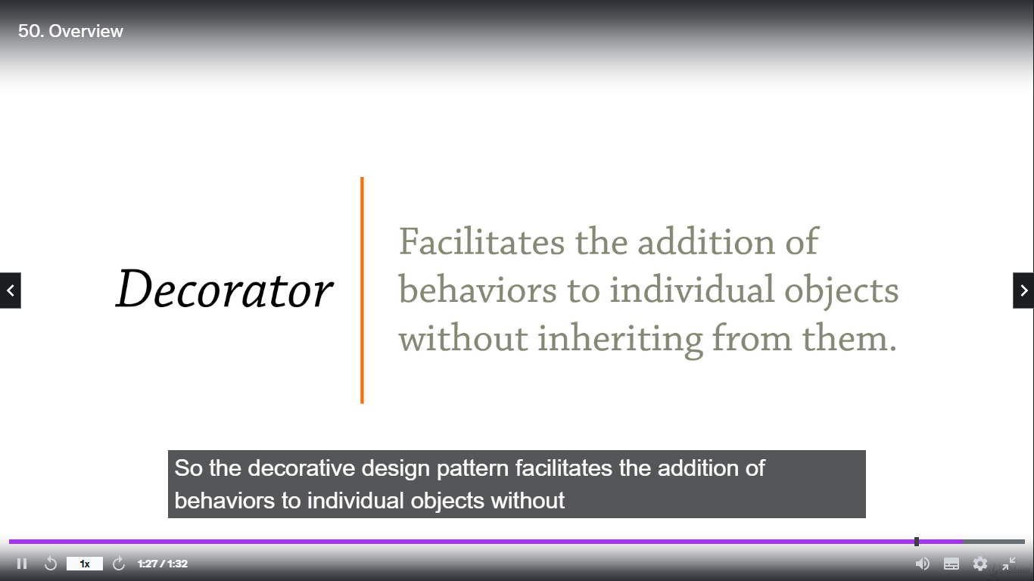

**“Adding behavior without altering the class itself”**

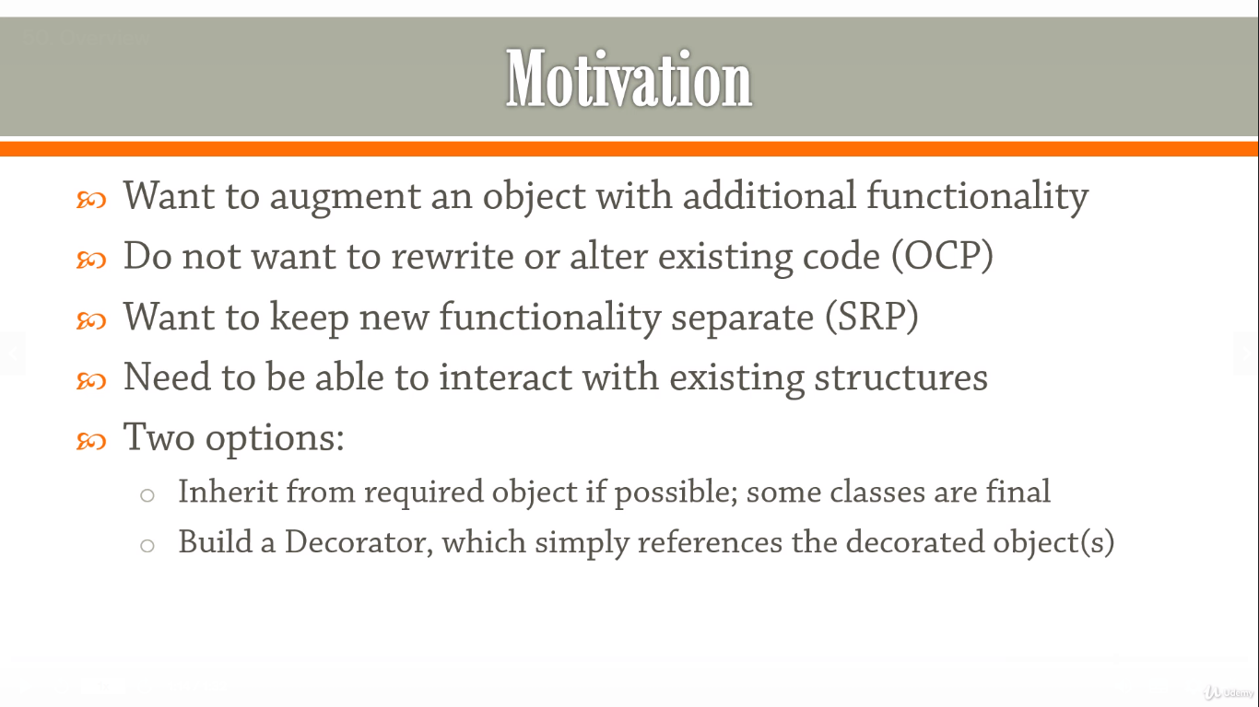

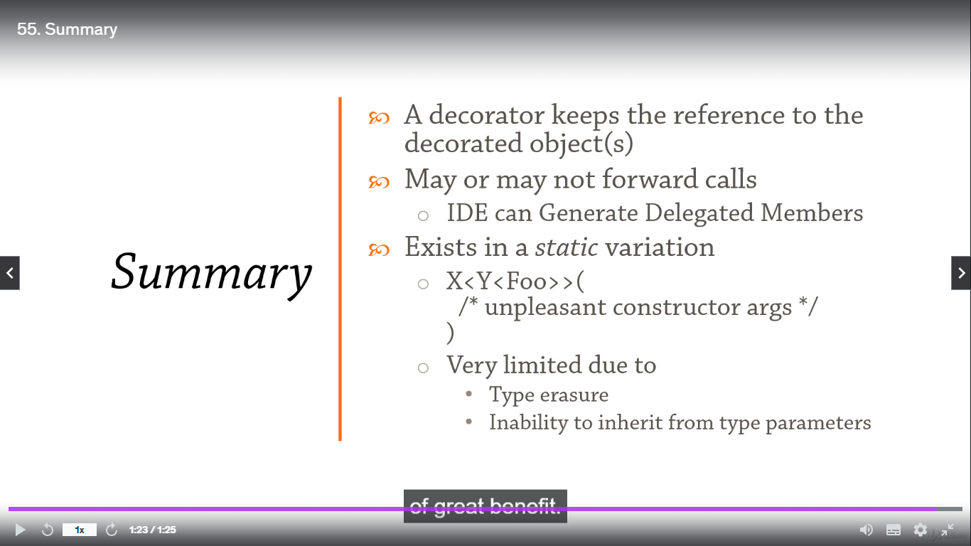

**Structural Design Patterns: Façade**

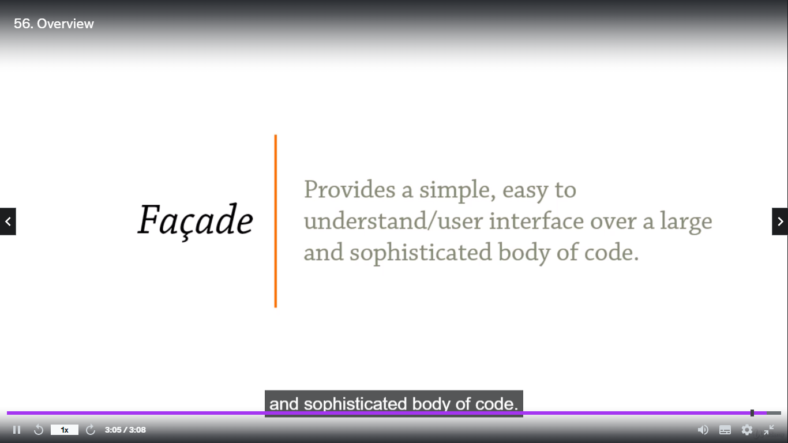

**“Exposing several components through a single interface”**

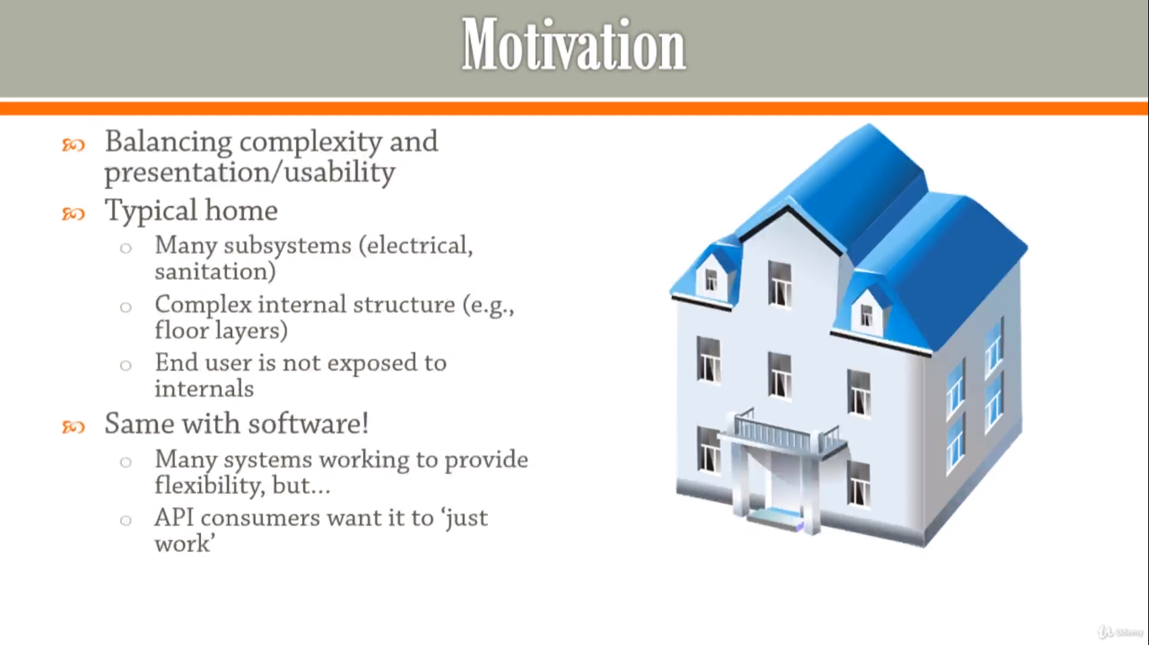

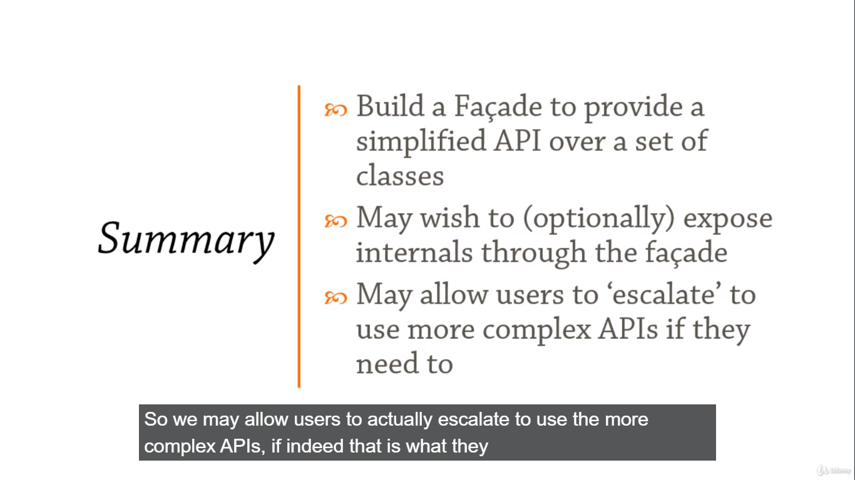

**Structural Design Patterns: Flyweight**

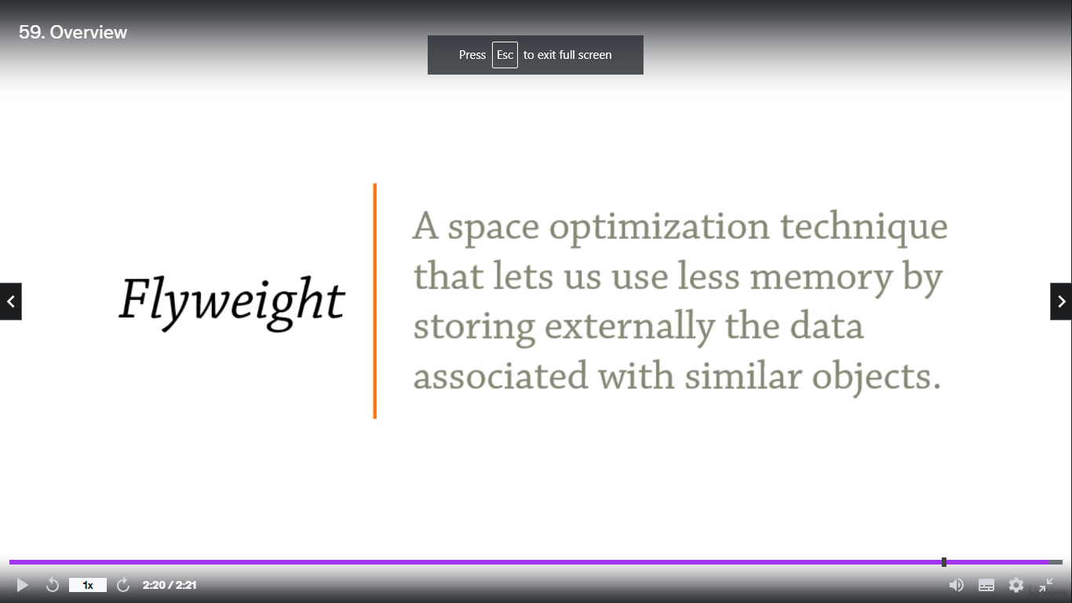

**“Space optimization!”**

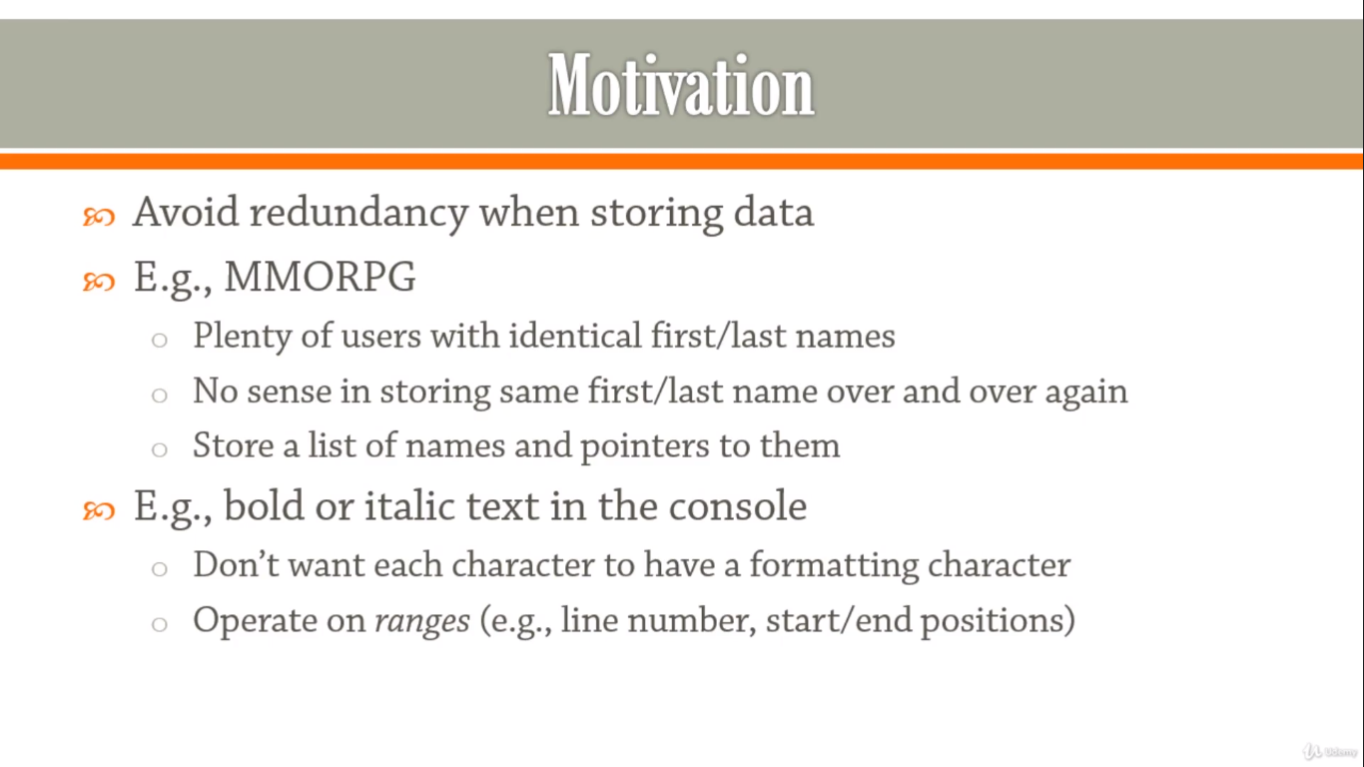

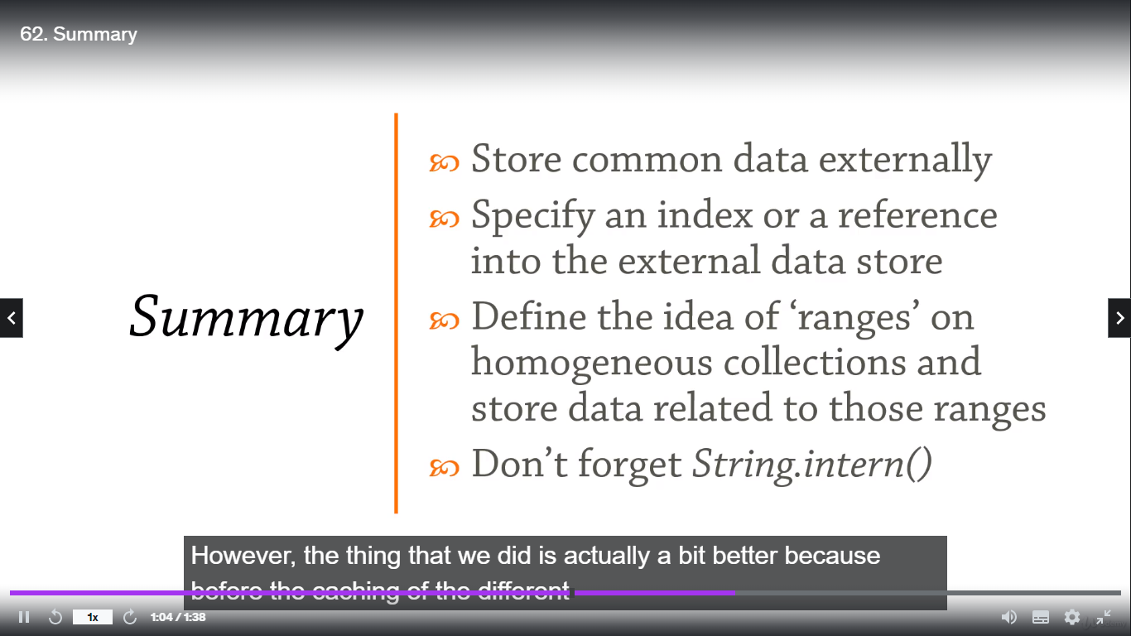

**Structural Design Patterns: Proxy**

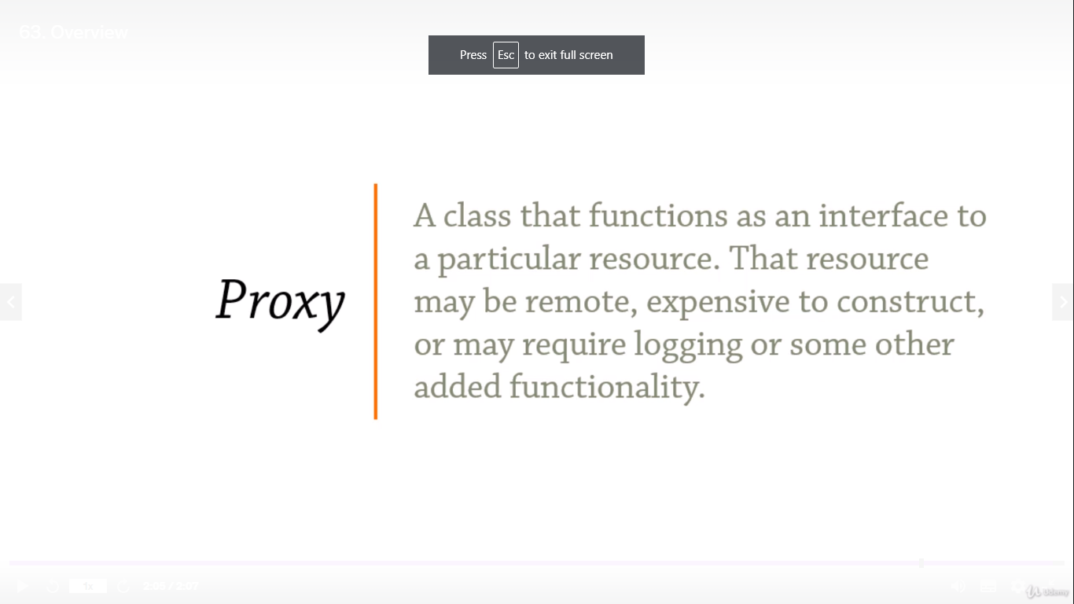

**“An interface for accessing a particular resource”**

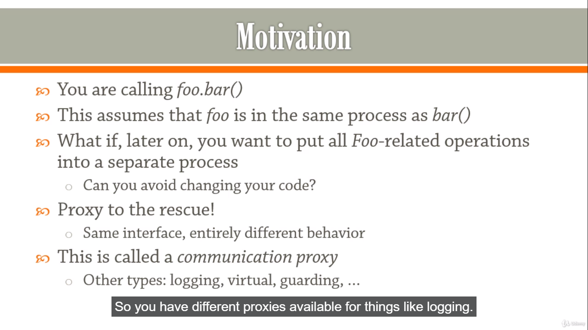

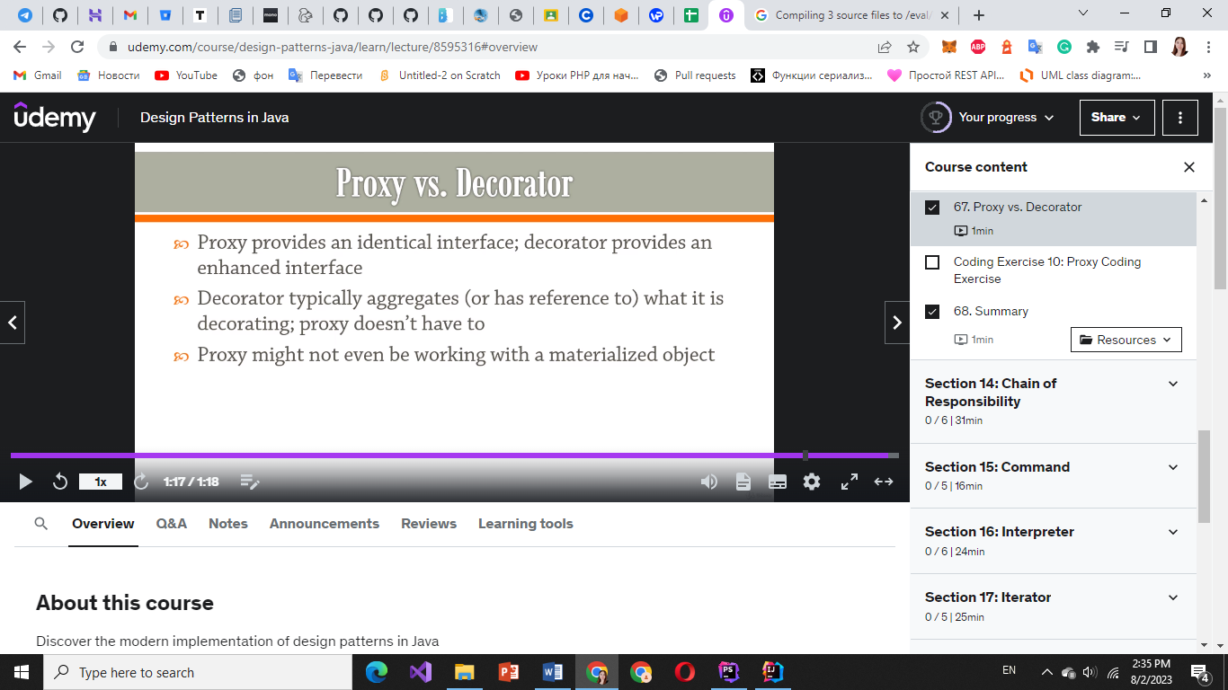

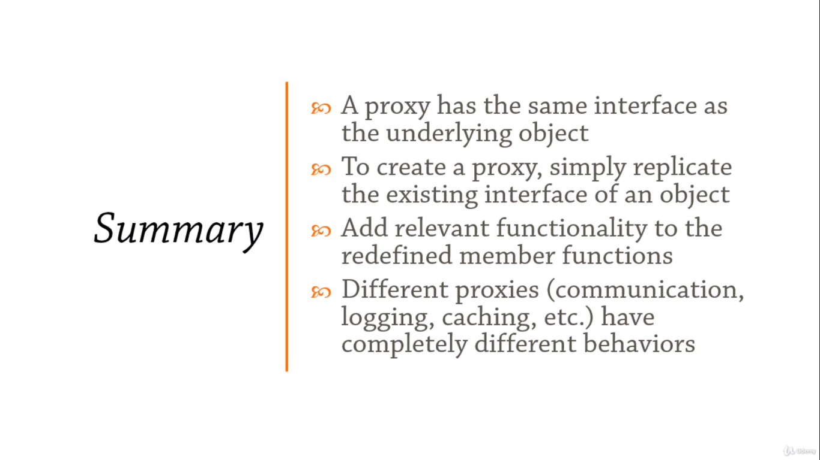

**Behavioral Design Patterns: Chain Of Responsibility**

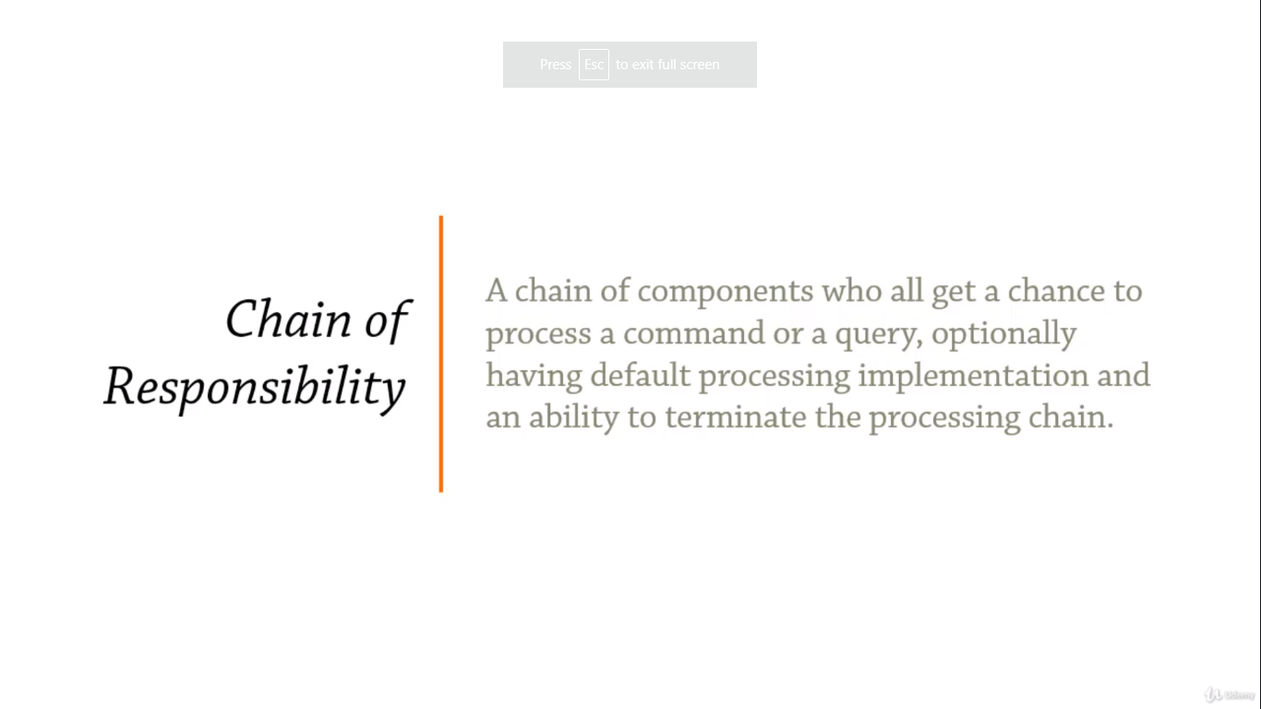

**“Sequence of handlers processing an event one after another”**

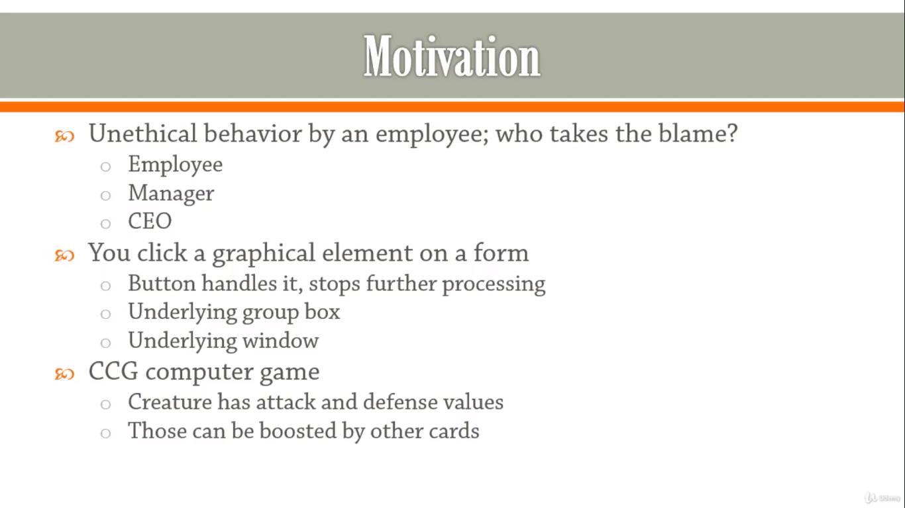

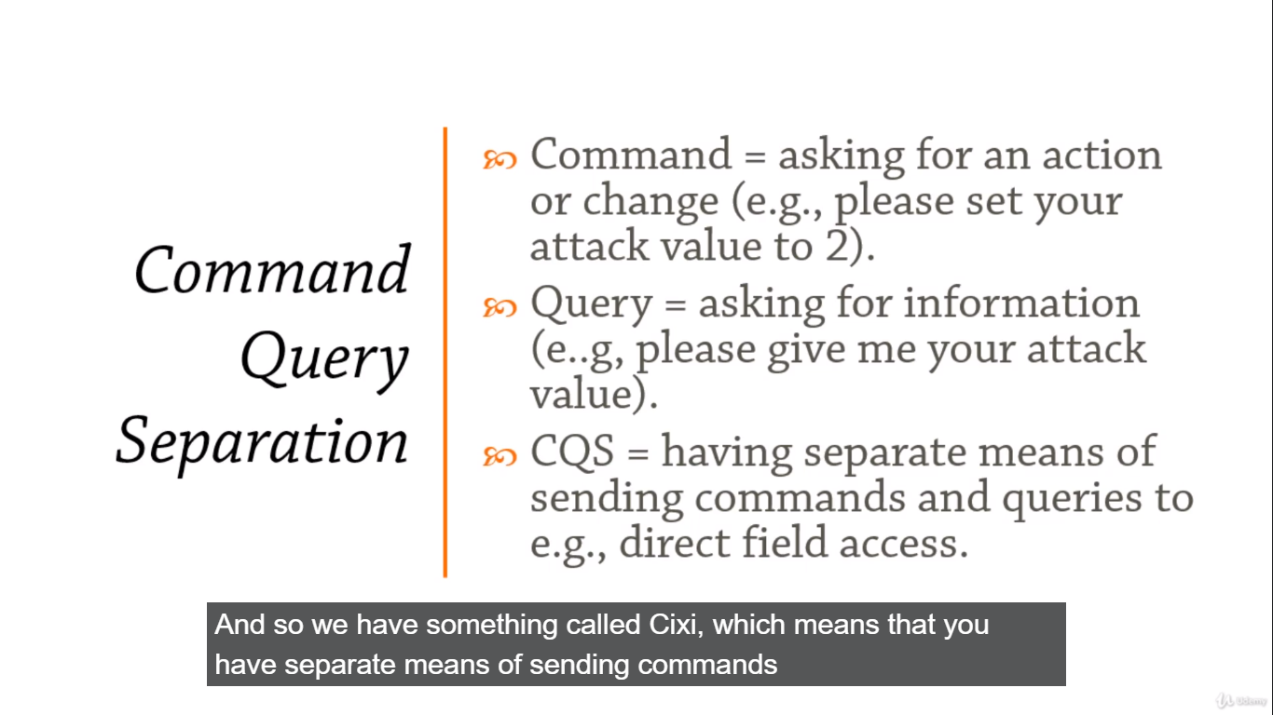

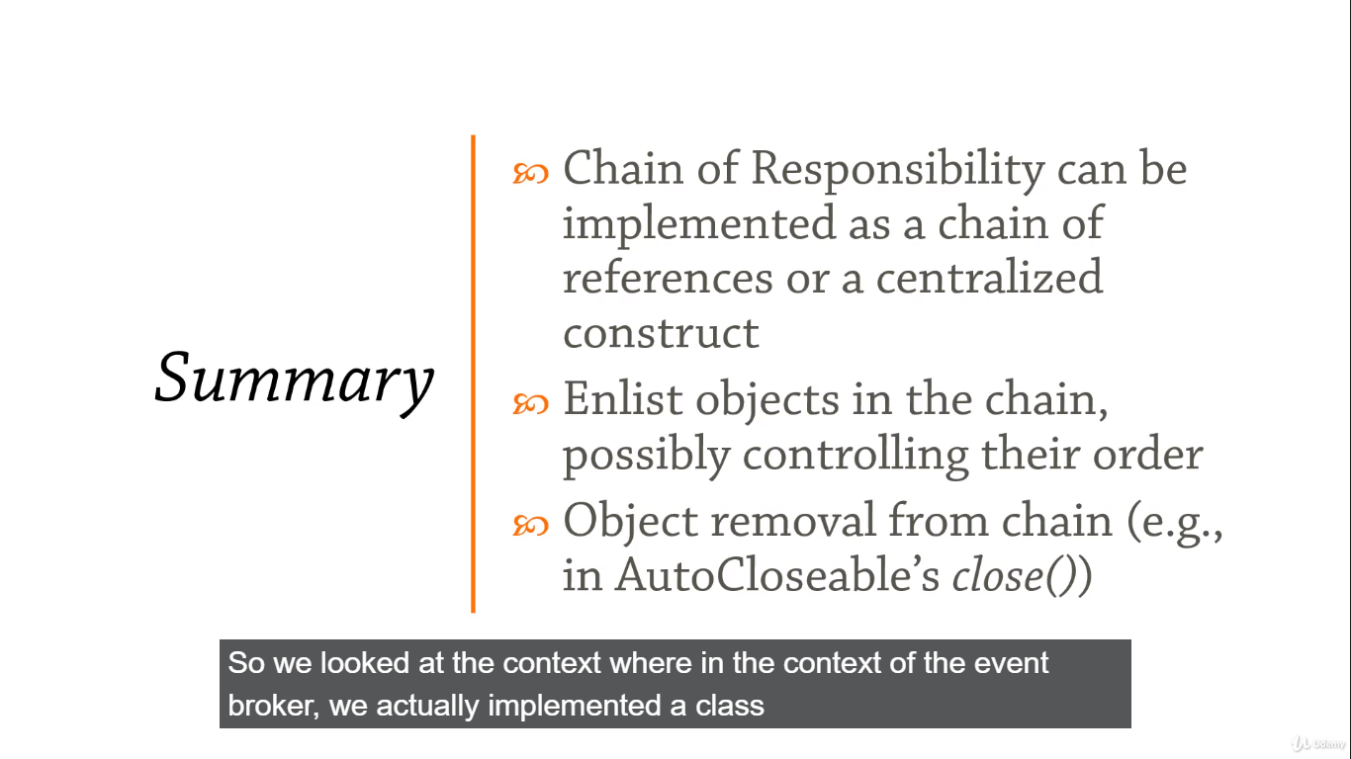

**Behavioral Design Patterns: Command**

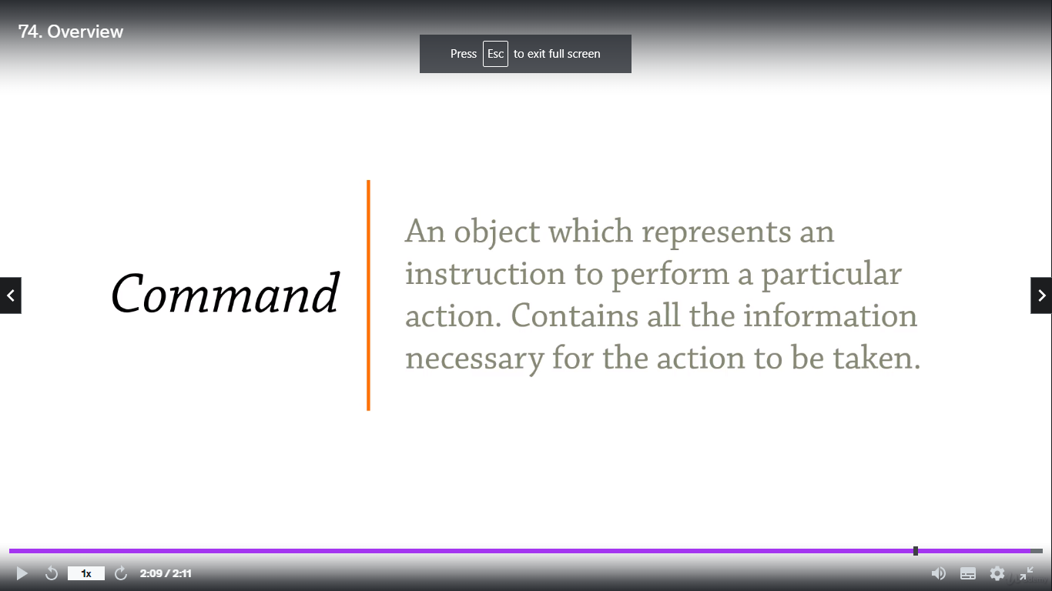

**“You shall not pass!”**

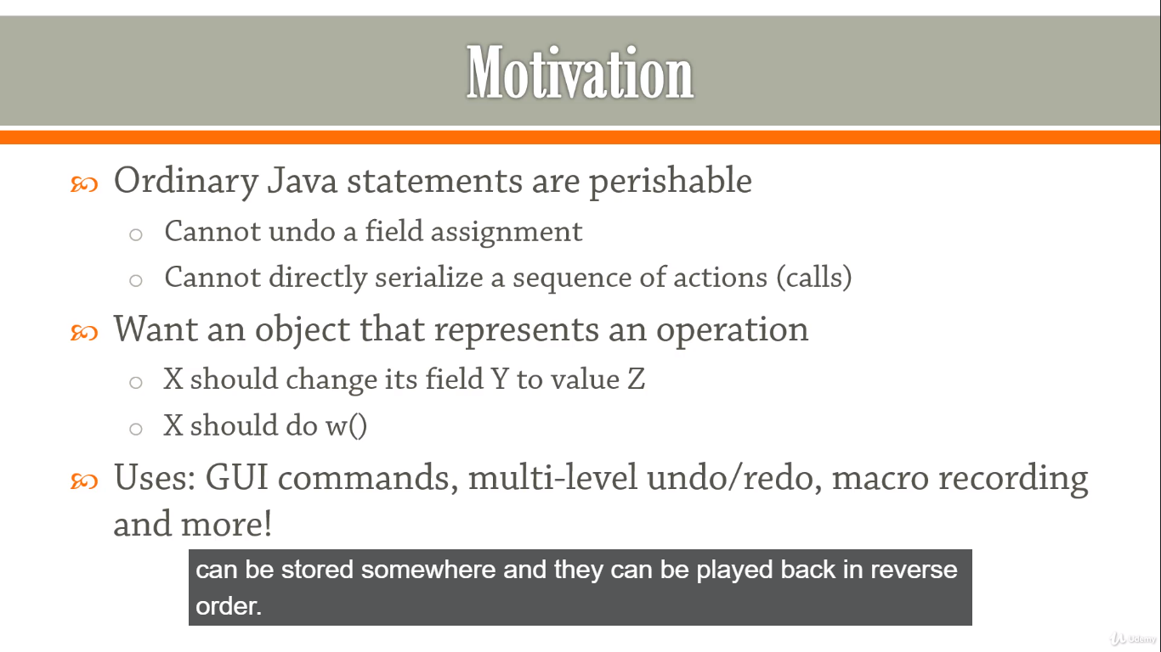

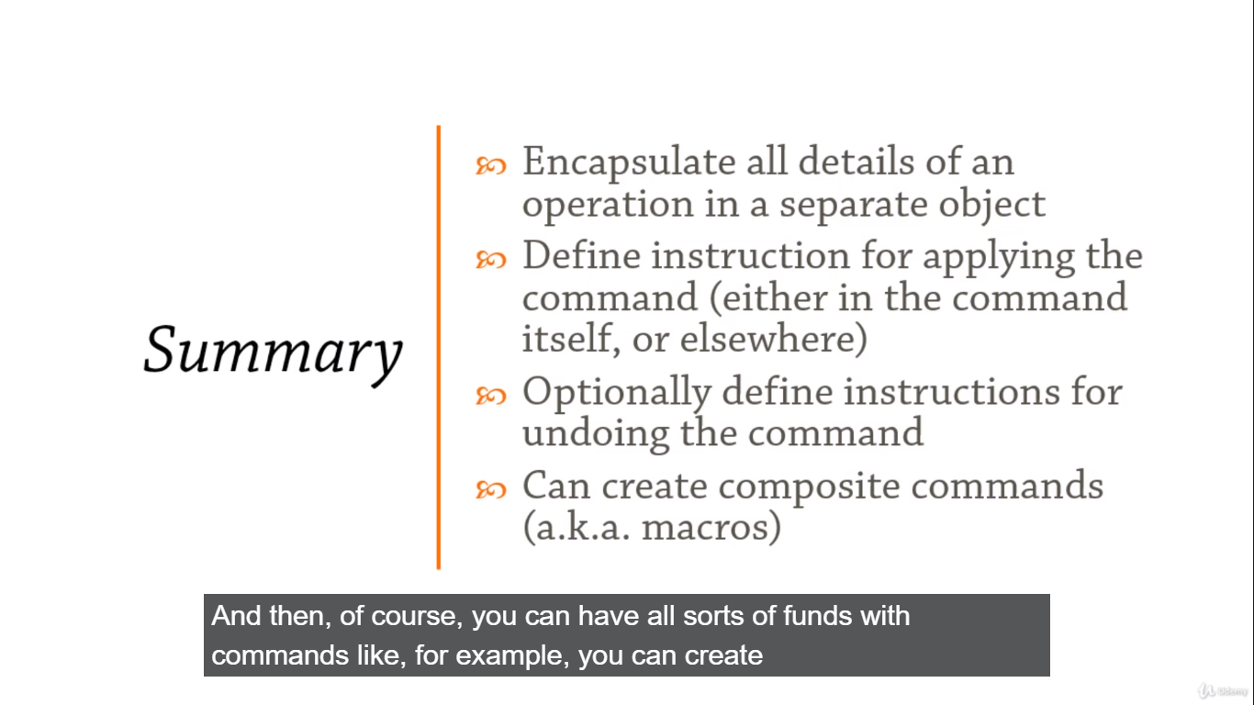

**Behavioral Design Patterns: Interpreter**

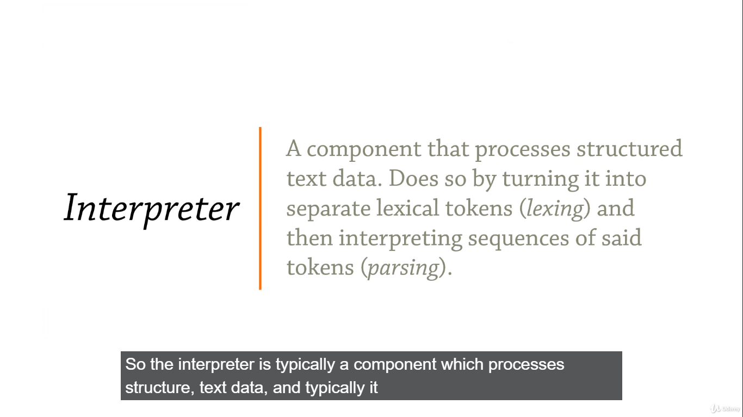

**“Interpreters are all around us. Even now, in this very room”**

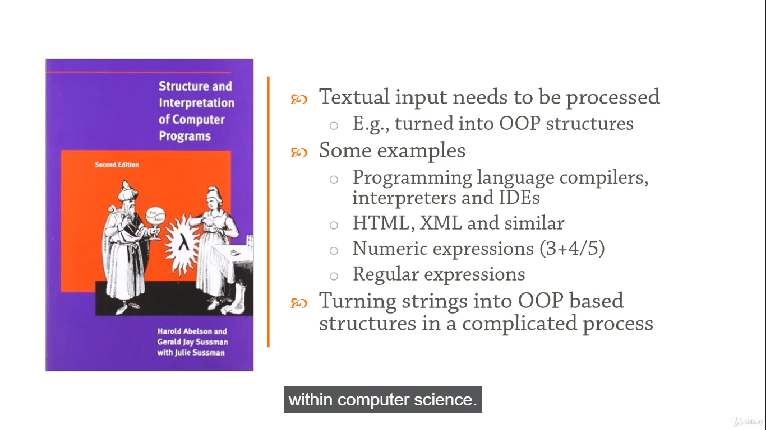

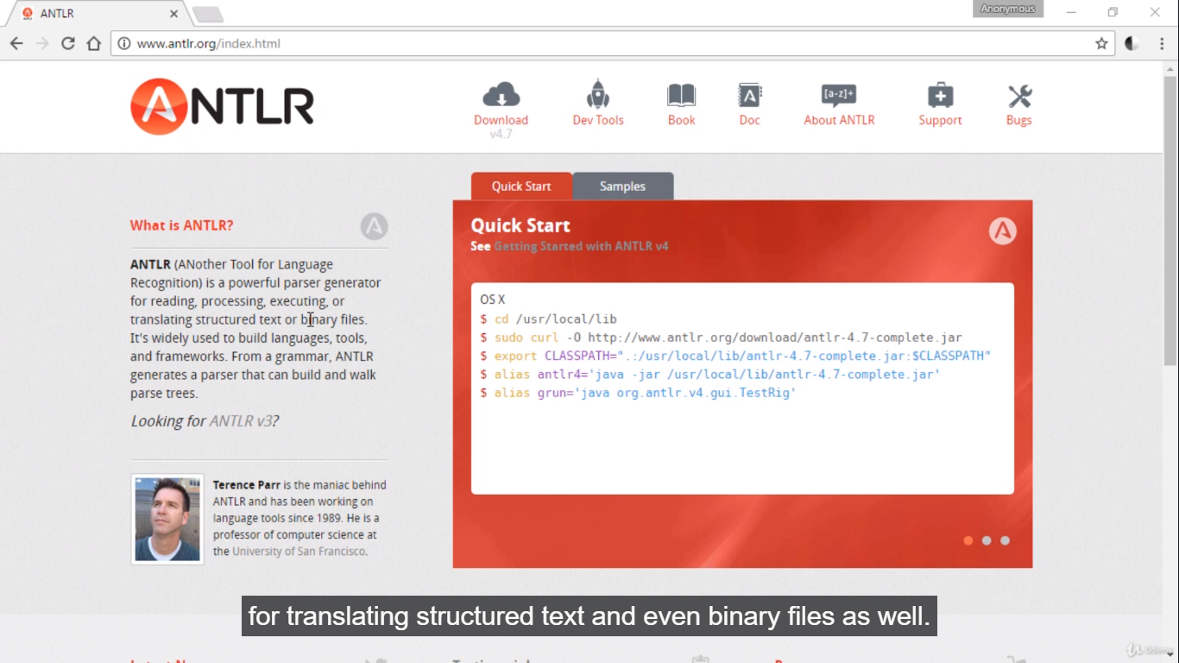**ANTLR (Another Tool For Language Recognition)** is a powerful parser generator for reading, processing, executing, or translating structured text or binary files. It is widely used to build languages, tools, and frameworks. From a grammar, ANTLR generates a parser that can build and walk parse trees.

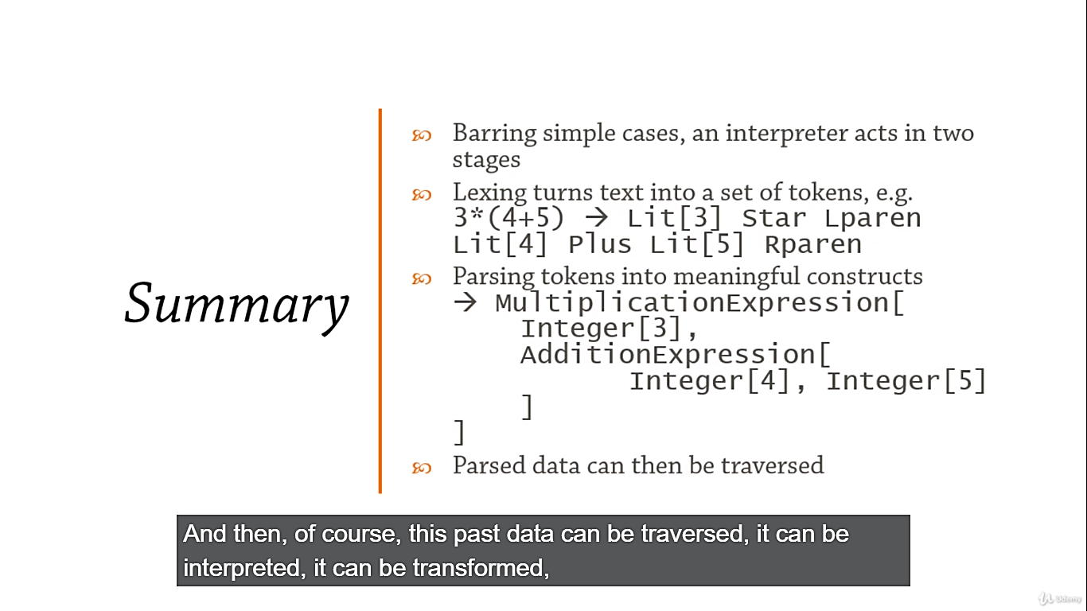

**Behavioral Design Patterns: Iterator**

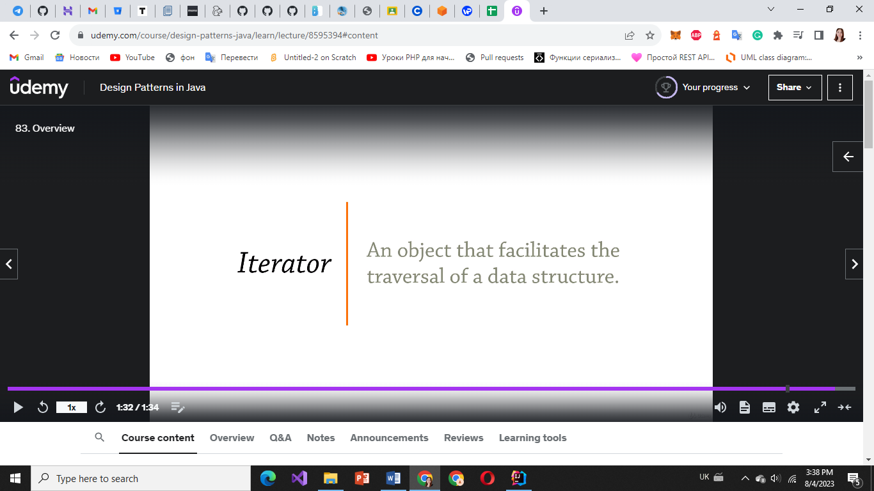

**“How traversal of data structures happens and makes it happen”**

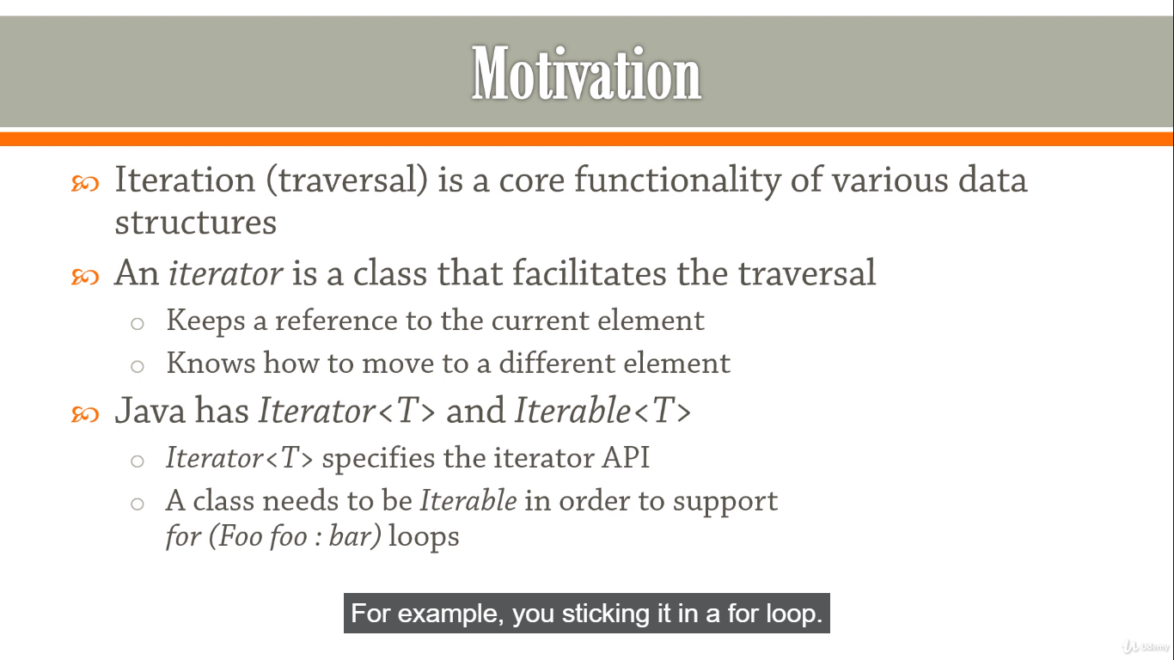

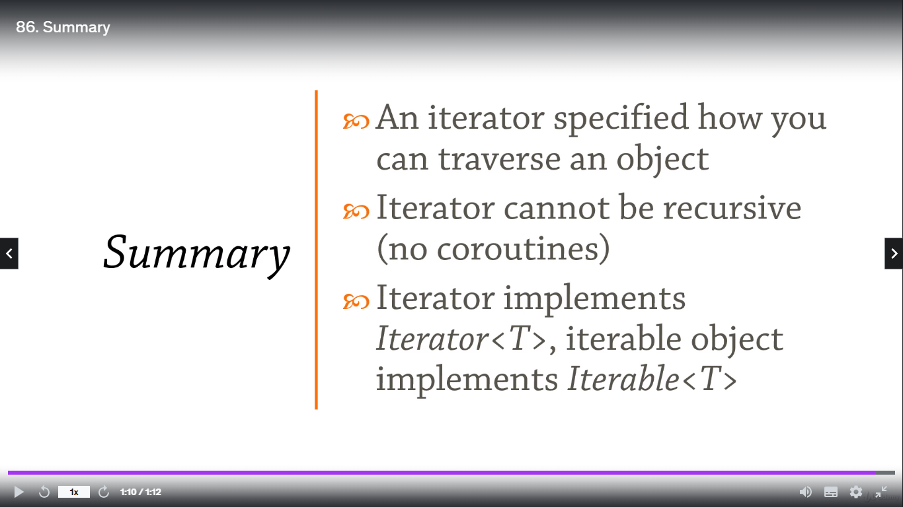

**Behavioral Design Patterns: Mediator**

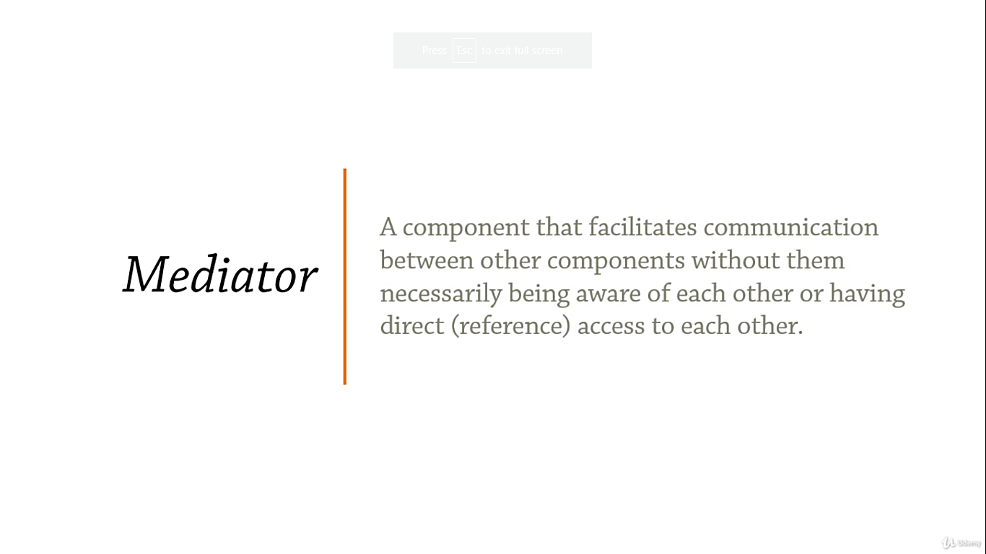

**“Facilitates communication between components”**

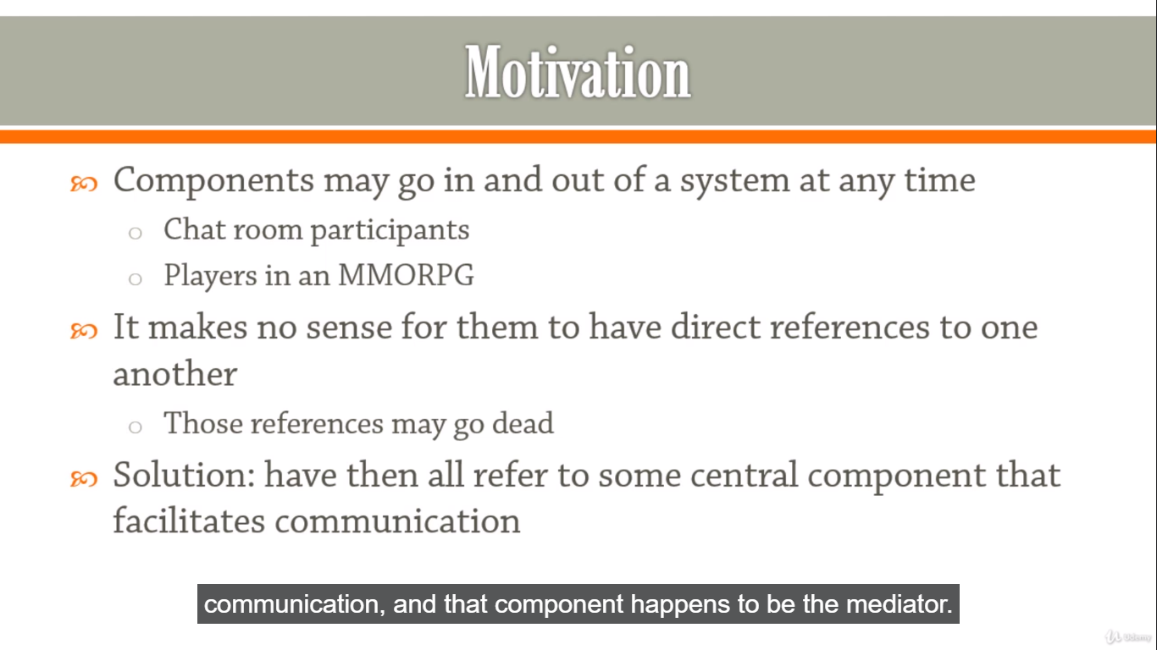

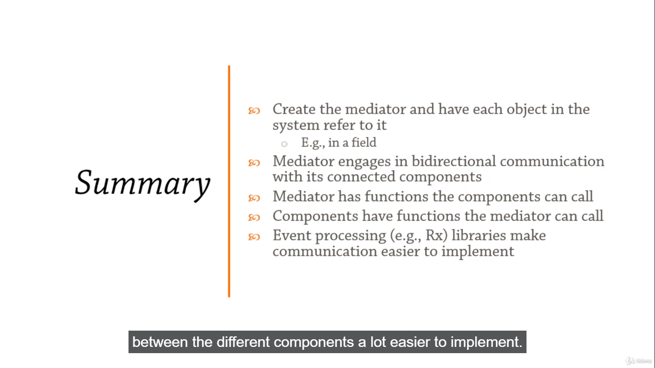

**Behavioral Design Patterns: Memento**

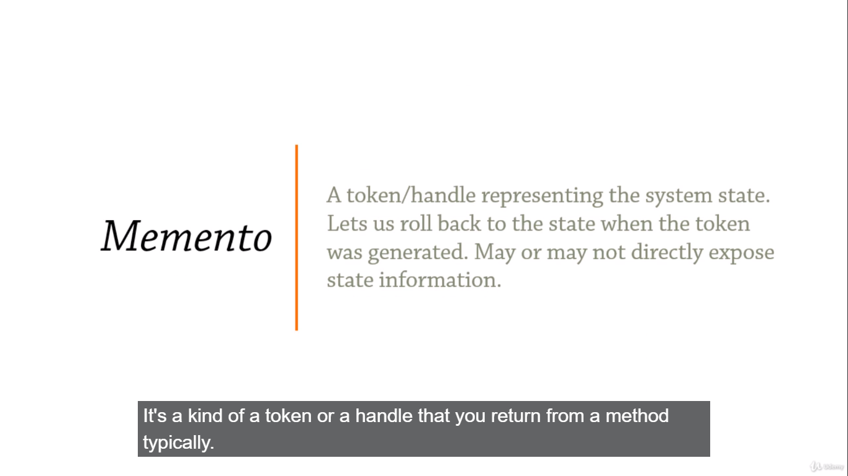

**“Keep a memento of an object’s state to return to that state.”**

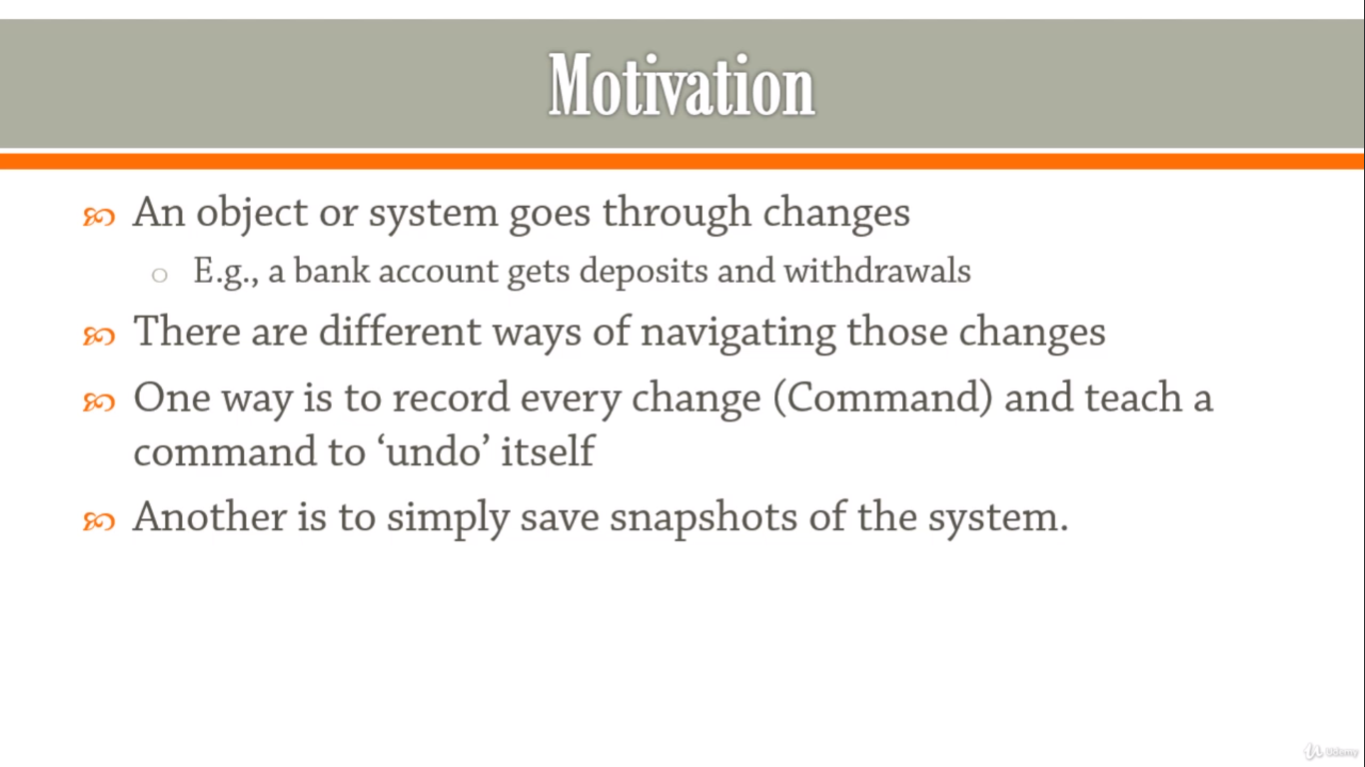

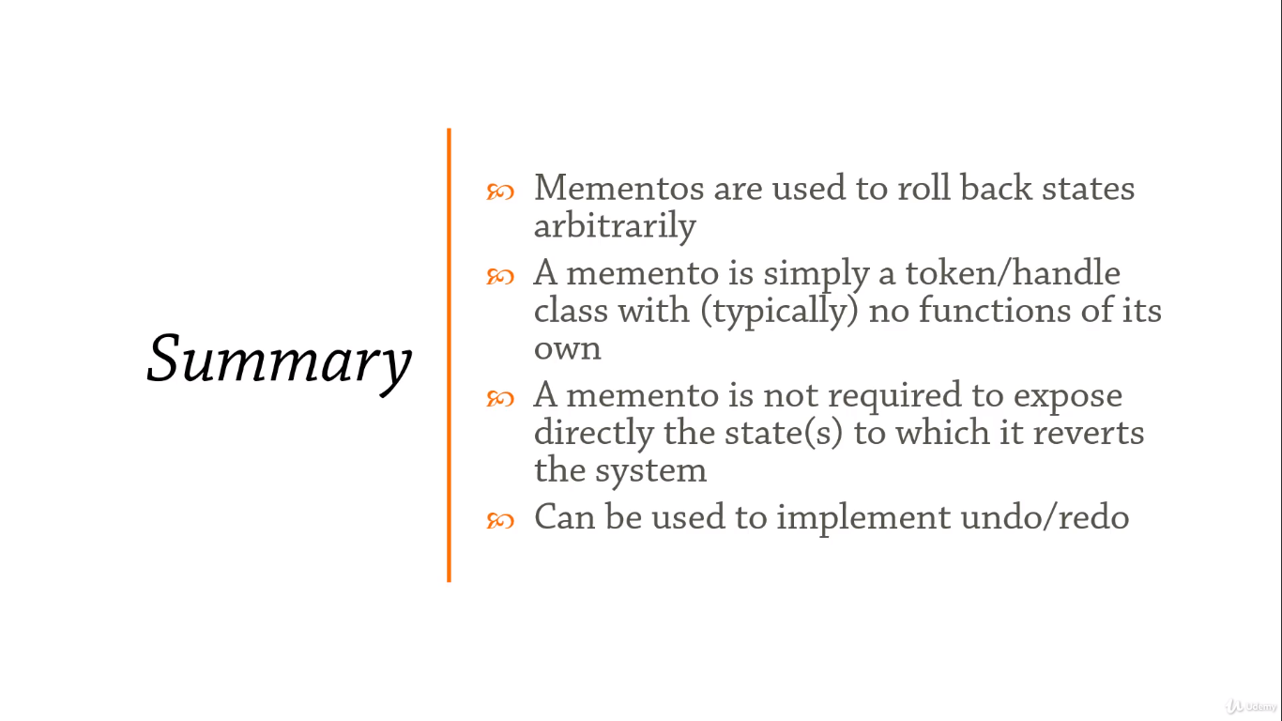

**Behavioral Design Patterns: Null Object**

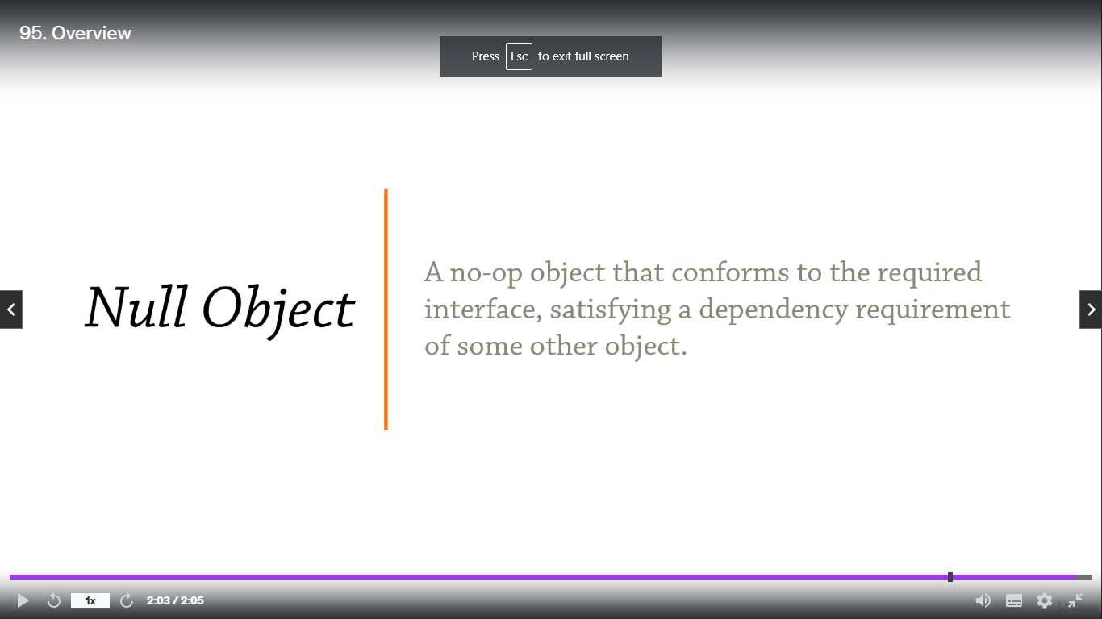

**“A behavioral design pattern with no behaviors”**

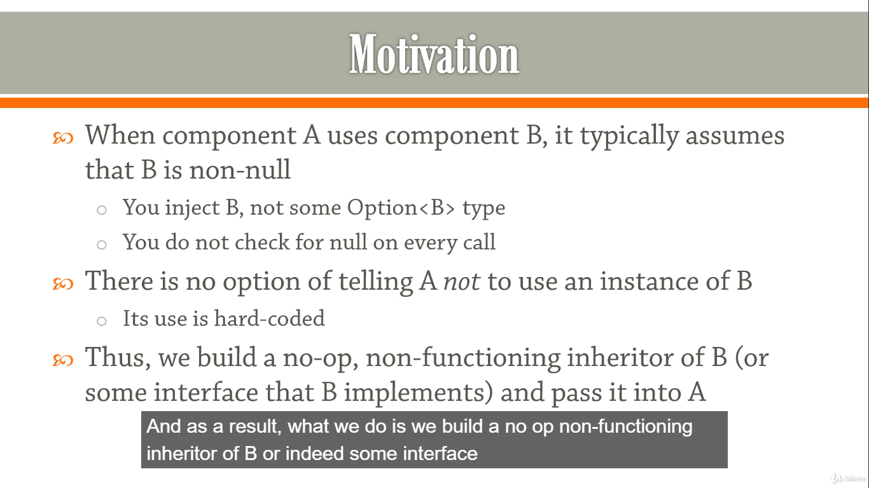

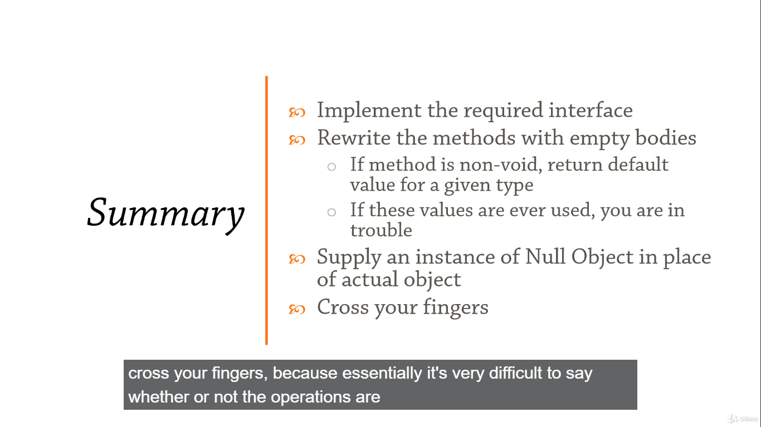

**Behavioral Design Patterns: Observer**

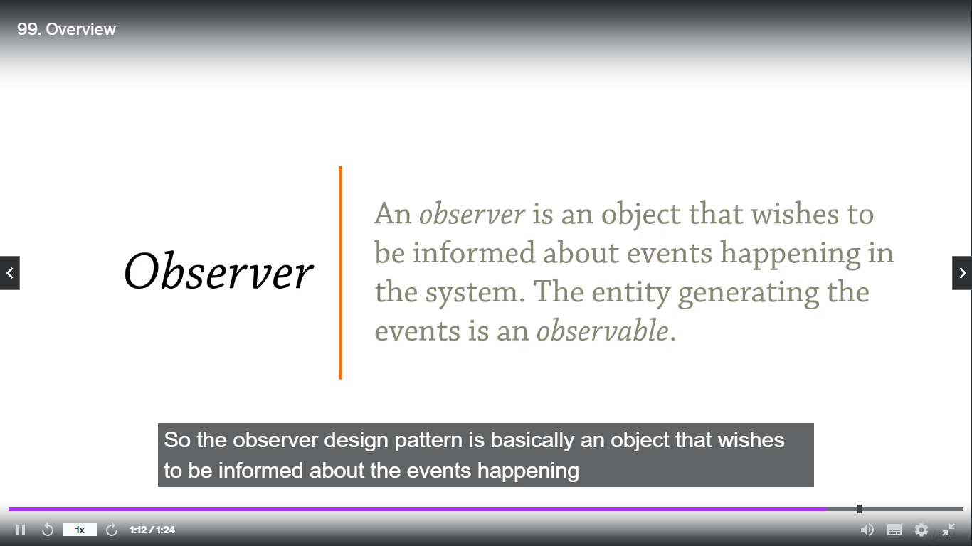

**“I am watching you!”**

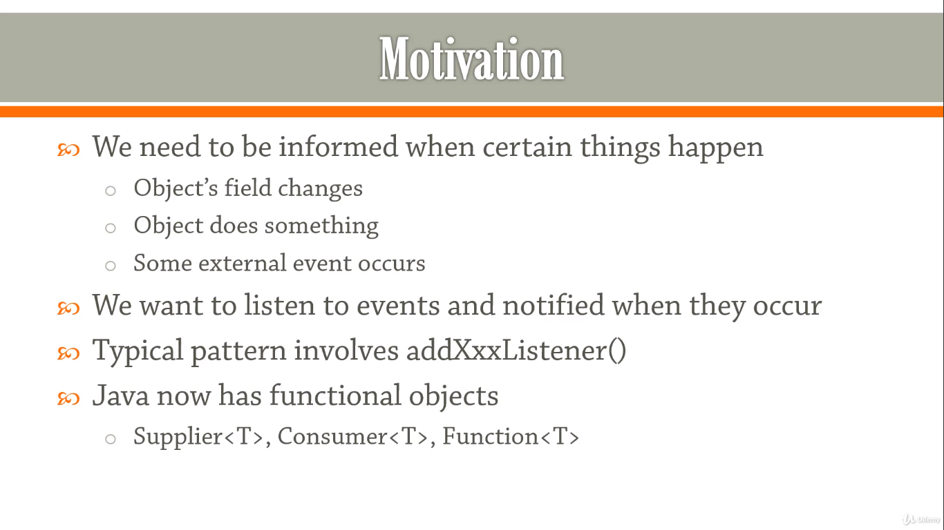

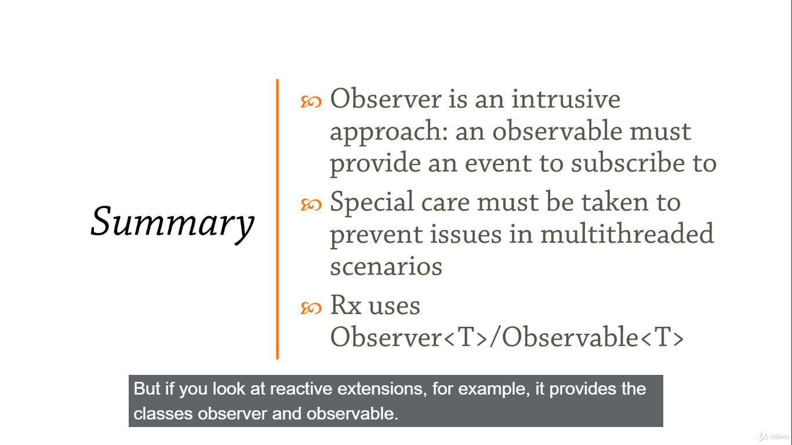

**Behavioral Design Patterns: State**

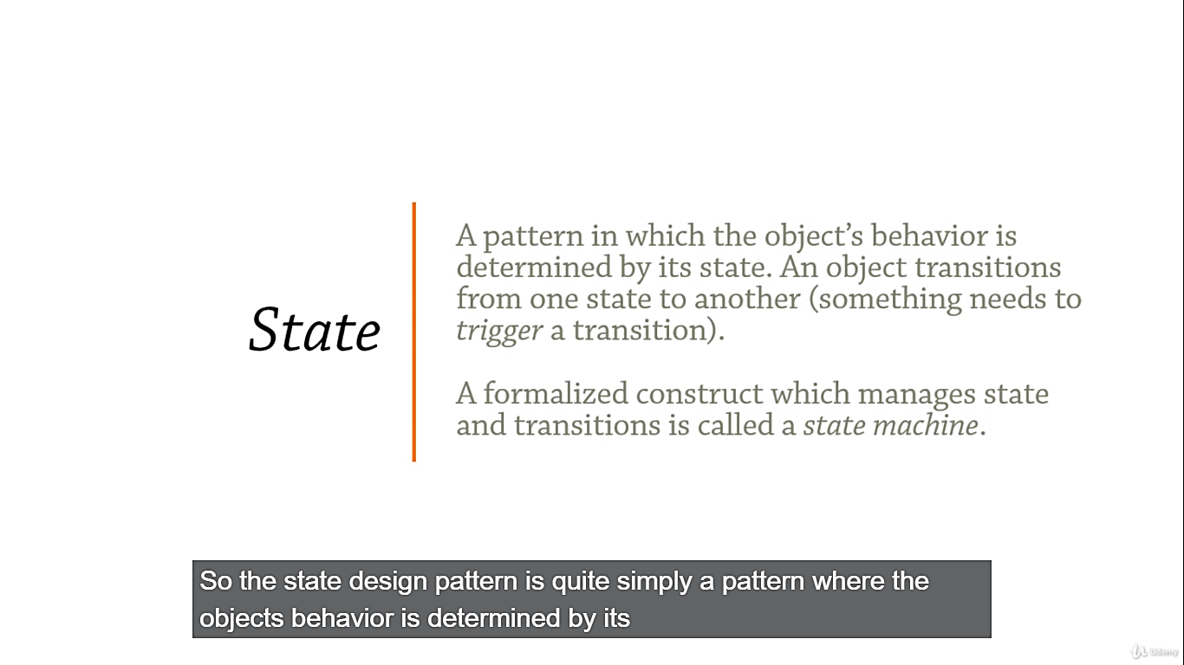

**“Fun with Finite State Machine”**

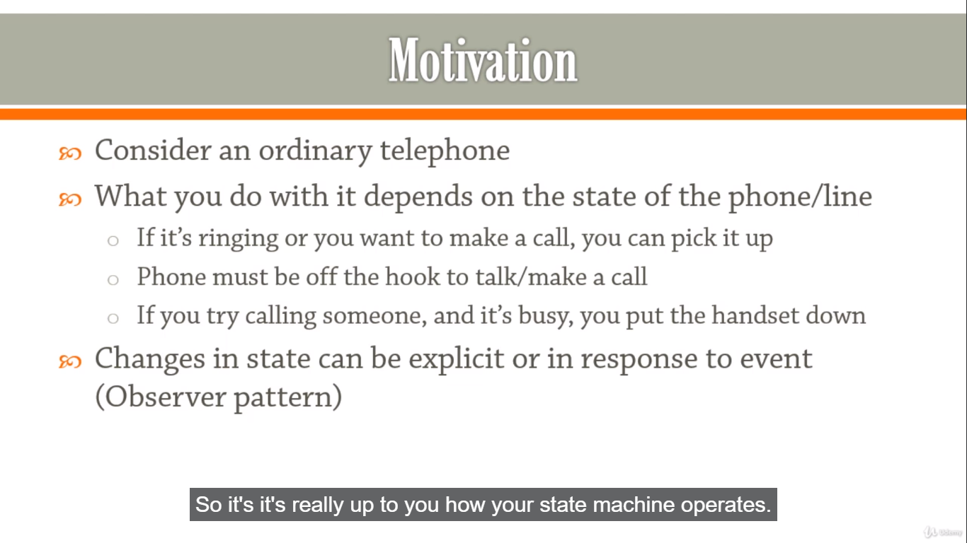

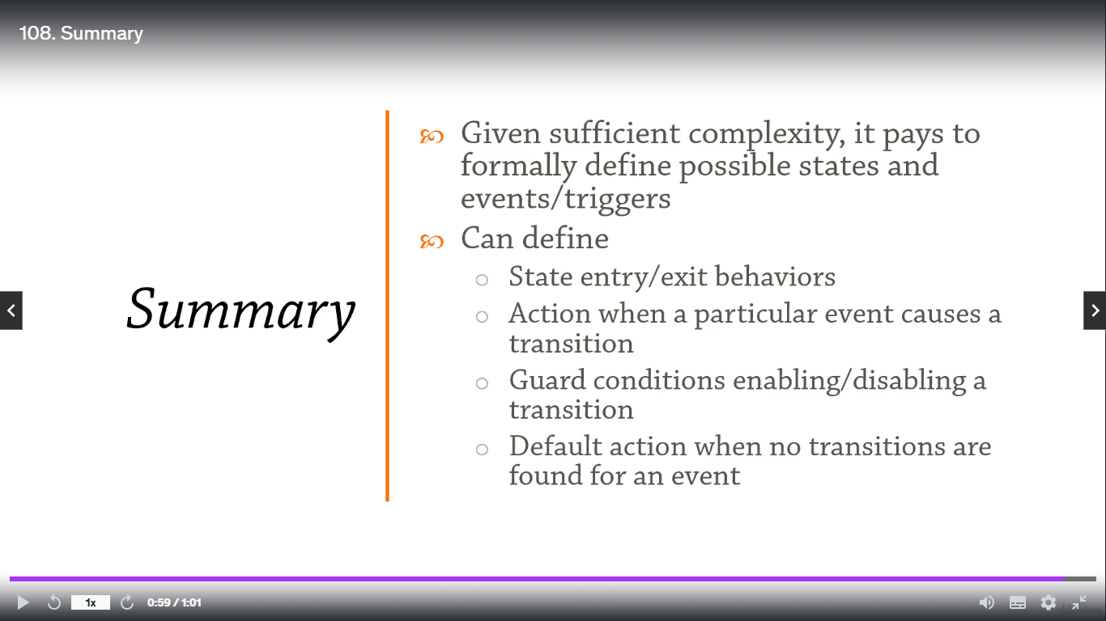

**Behavioral Design Patterns: Strategy**

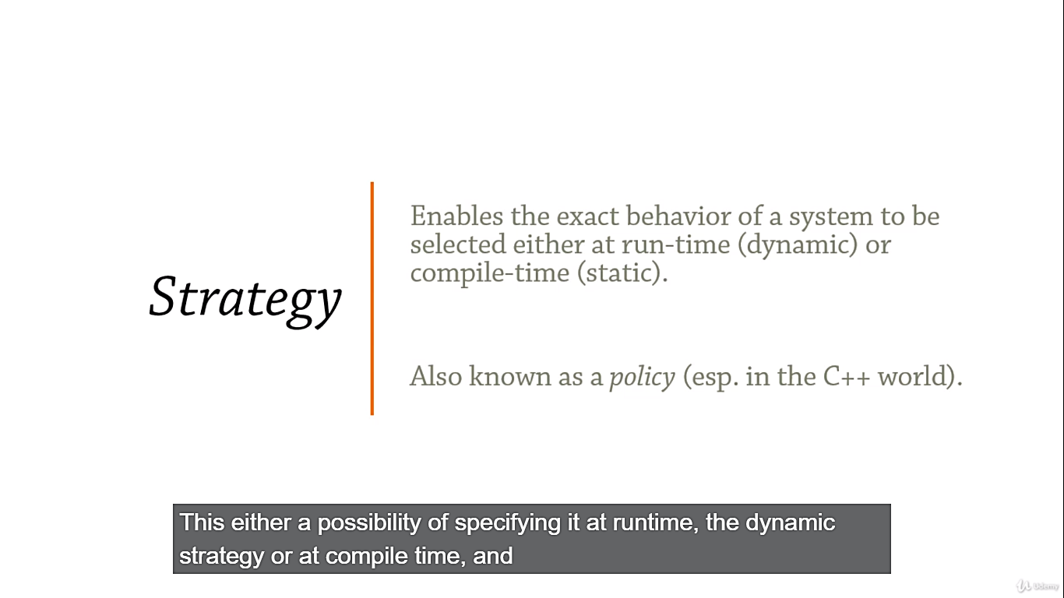

**“System behavior partially specified at runtime”**

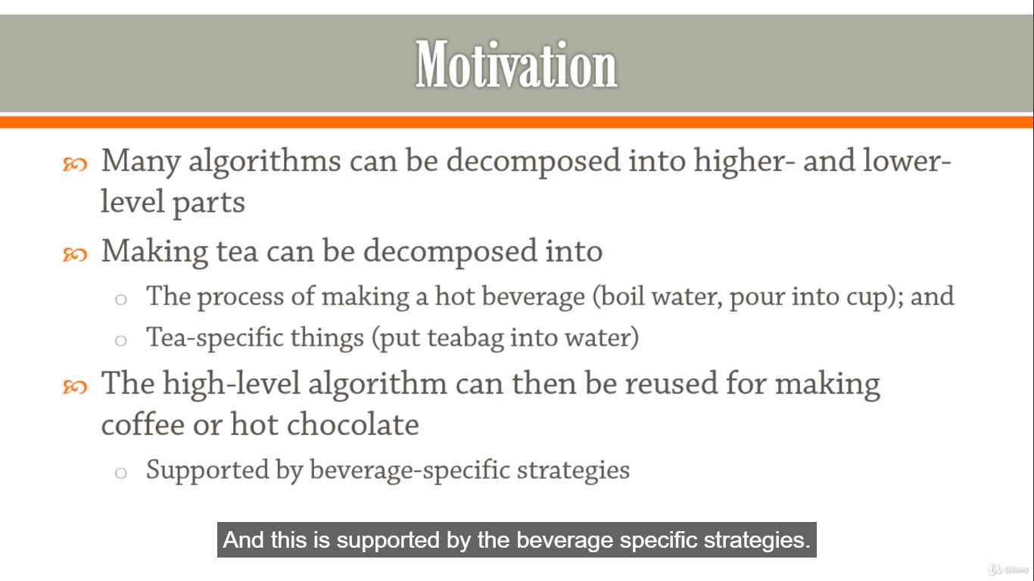

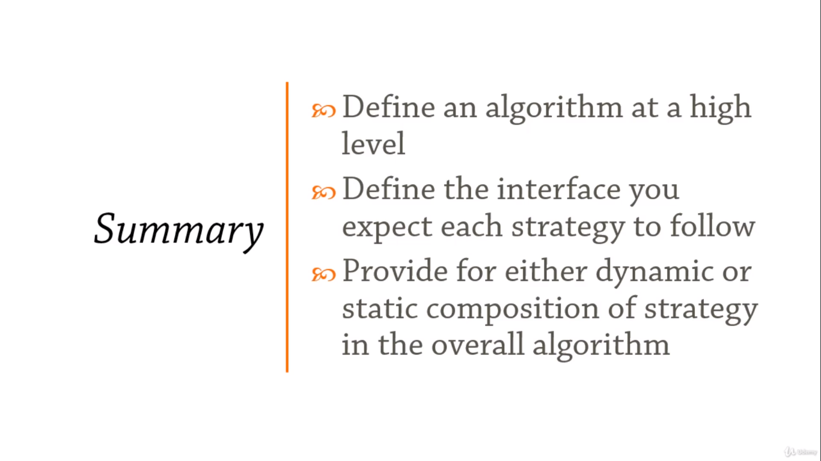

**Behavioral Design Patterns: Template**

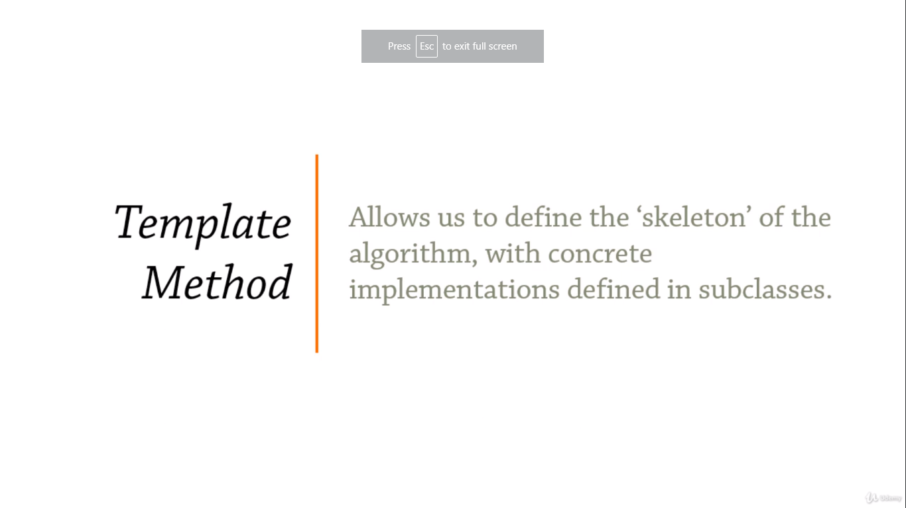

**“A high-level blueprint for an algorithm to be completed by inheritors”**

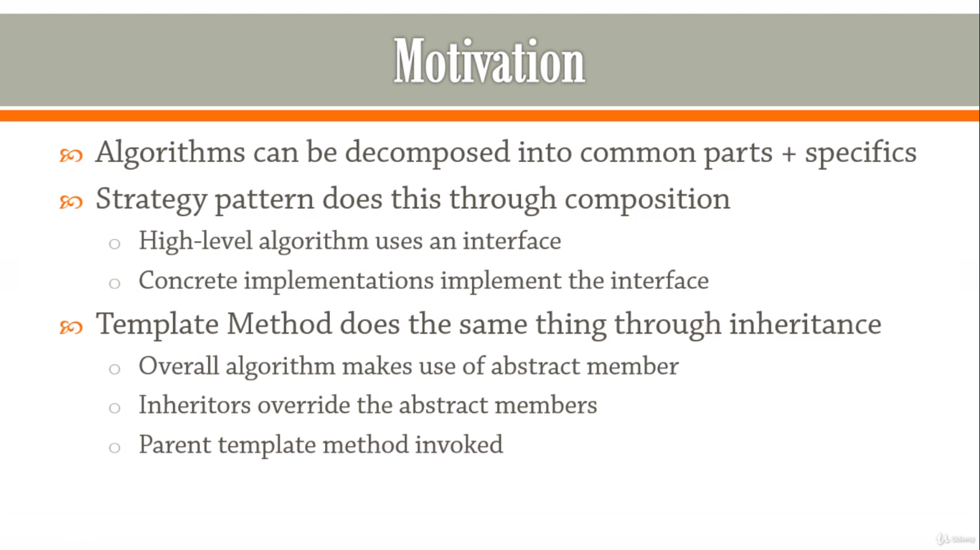

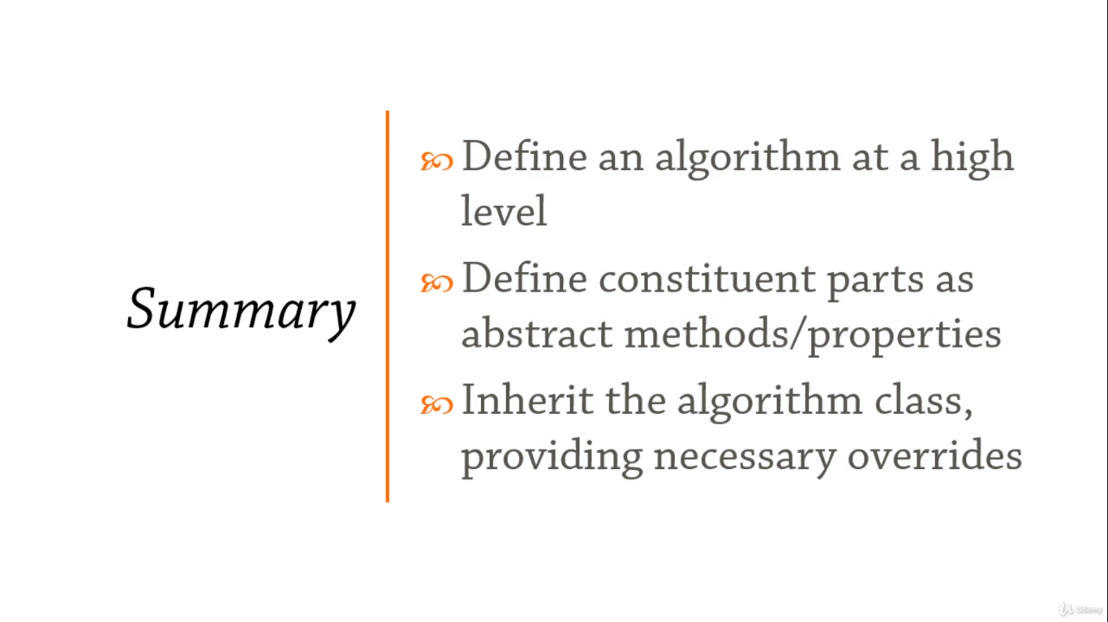

**Behavioral Design Patterns: Visitor**

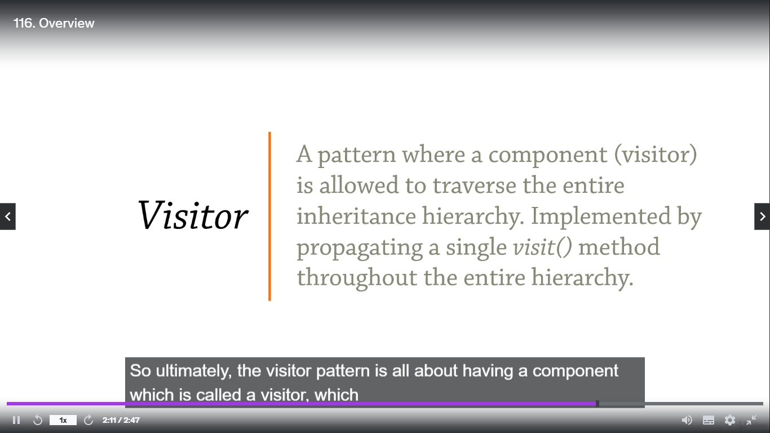

**“Allows adding extra behaviors to entire hierarchies of classes”**

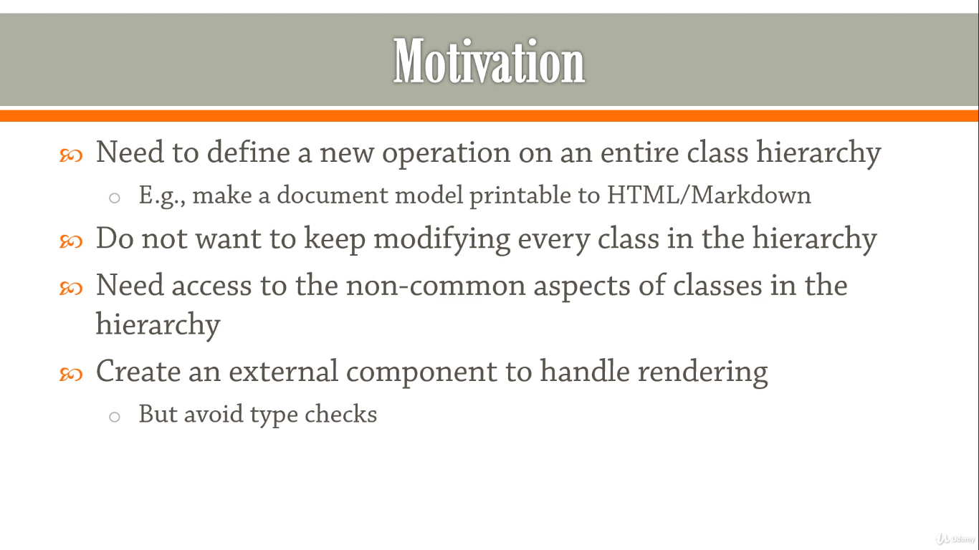

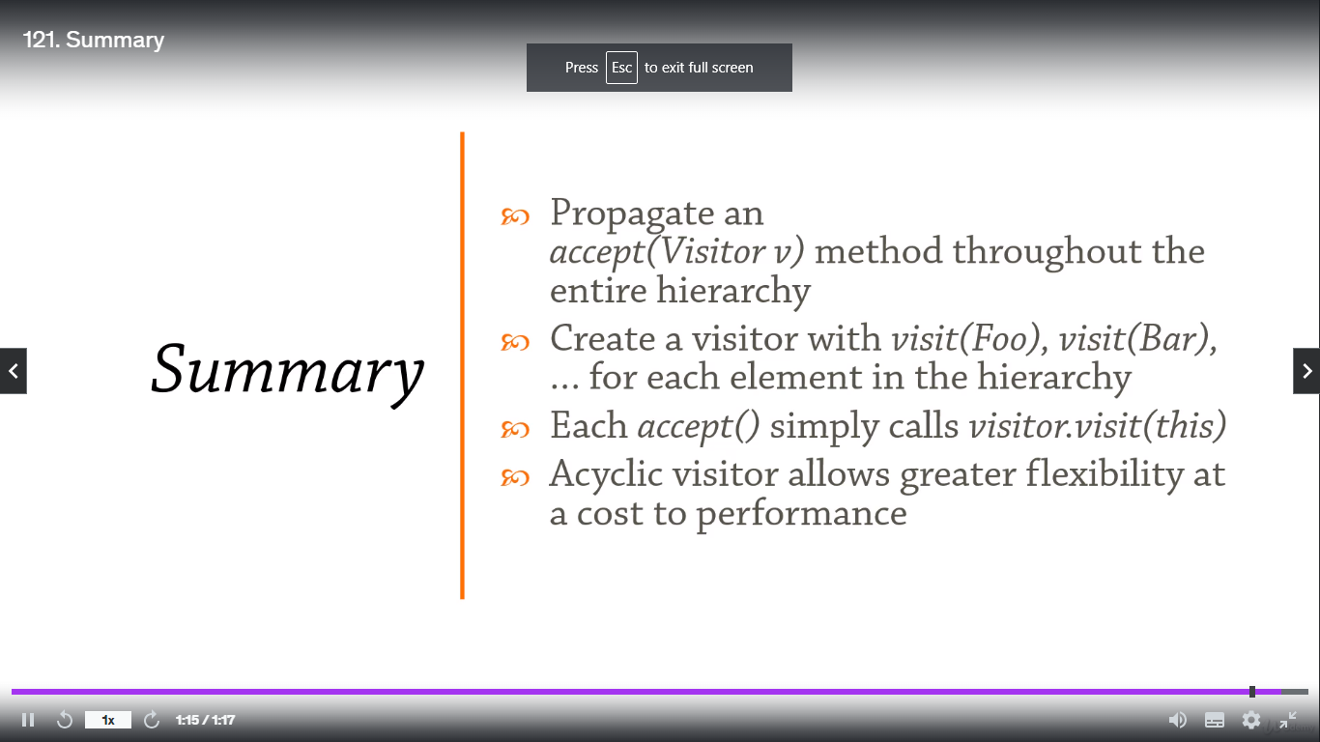

**The End of The Course**

